VPC Tasks
- Create a VPC with 2 private and 2 public subnets.
Objective: The objective of this task is to create a secure and scalable Virtual Private Cloud (VPC) environment in AWS using the “VPC and more” option available in the Amazon VPC console.
The implementation includes:
- 1 Custom VPC
- 2 Public Subnets
- 2 Private Subnets
- Internet Gateway
- Route Tables
- Multi-AZ architecture
This setup provides secure network segmentation and prepares the infrastructure for deploying applications, databases, and cloud services.
Expected Outcome
After successful implementation:
- A custom VPC is created successfully
- Two public subnets are available with internet access
- Two private subnets are isolated from direct internet access
- Internet Gateway is attached automatically
- Route tables are configured automatically
- Resources are distributed across multiple Availability Zones
- Infrastructure is ready for EC2, RDS, Load Balancer, and Kubernetes deployments
Prerequisites
Before starting, ensure the following requirements are available.
Account Requirements
- Active AWS account
- Access to AWS Management Console
Permissions Required
The IAM user should have permissions for:
- VPC
- Subnets
- Route Tables
- Internet Gateway
- NAT Gateway
- EC2
Environment Details
Component | Value
Region | us-east-2 (Ohio)
VPC CIDR | 10.0.0.0/16
Public Subnets | 2
Private Subnets | 2
Availability Zone 1 | us-east-2a
Availability Zone 2 | us-east-2b

Implementation Steps
Step 1: Log in to the AWS Console
- Open AWS Console
- Navigate to:
Services → VPC
- Open the VPC Dashboard

Step 2: Create VPC
- Click:
Create VPC
- Under Resources to create, select:
VPC and more
This option automatically creates networking resources required for the VPC setup.
Step 3: Configure VPC Settings
Enter the following details:
Setting | Value
Name tag auto-generation | demo
IPv4 CIDR block | 10.0.0.0/16
IPv6 CIDR block | No IPv6 CIDR Block
Tenancy | Default
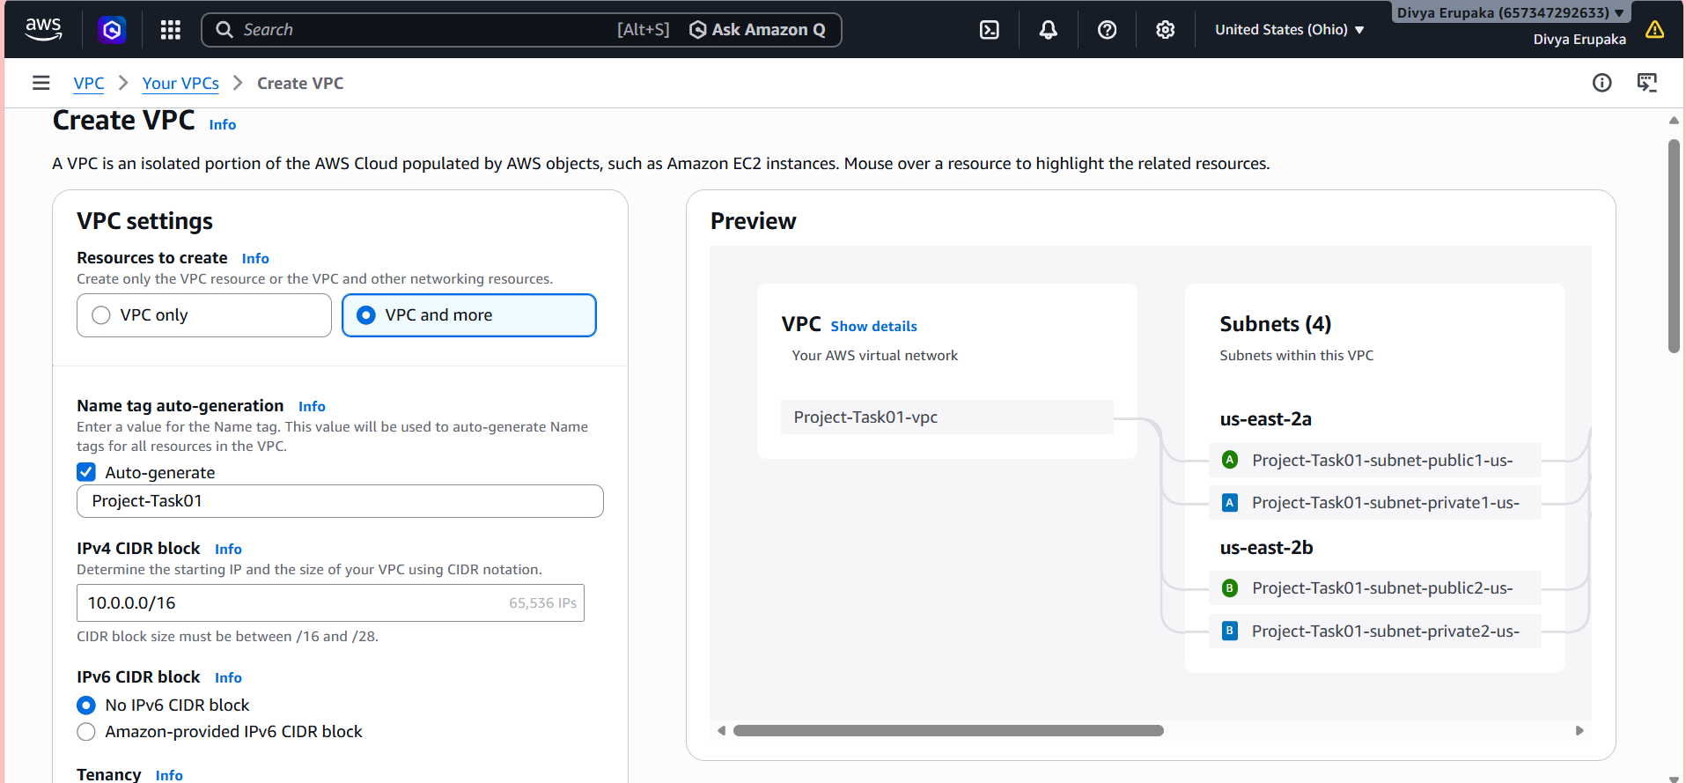Step 4: Configure Availability Zones and Subnets
Configure the subnet settings:
Setting | Value
Number of Availability Zones | 2
Number of Public Subnets | 2
Number of Private Subnets | 2
AWS automatically distributes subnets across:
- us-east-2a
- us-east-2b
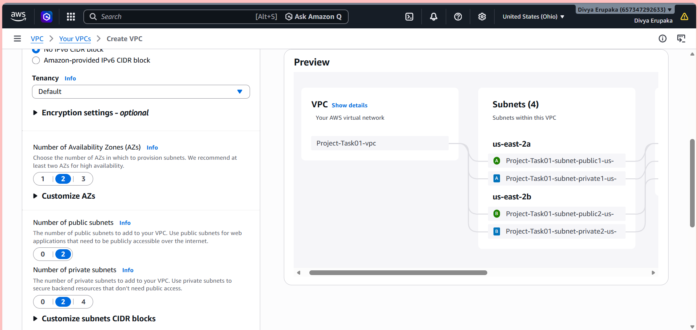
Step 5: Configure NAT Gateway
Under NAT Gateway settings:
Available options:
- None
- In 1 AZ
- 1 per AZ
For this implementation:
None
was selected.
This means:
- Private subnets do not have outbound internet access.
Step 6: Configure VPC Endpoints
Leave VPC Endpoints unchecked.
No S3 Gateway Endpoint was created for this task.
Step 7: Configure DNS Settings
Ensure the following options are enabled:
- Enable DNS hostnames
- Enable DNS resolution
These settings allow EC2 instances to resolve domain names correctly.
Step 8: Create VPC
Click:
Create VPC
AWS automatically creates:
- VPC
- Public subnets
- Private subnets
- Internet Gateway
- Route tables
- Route associations
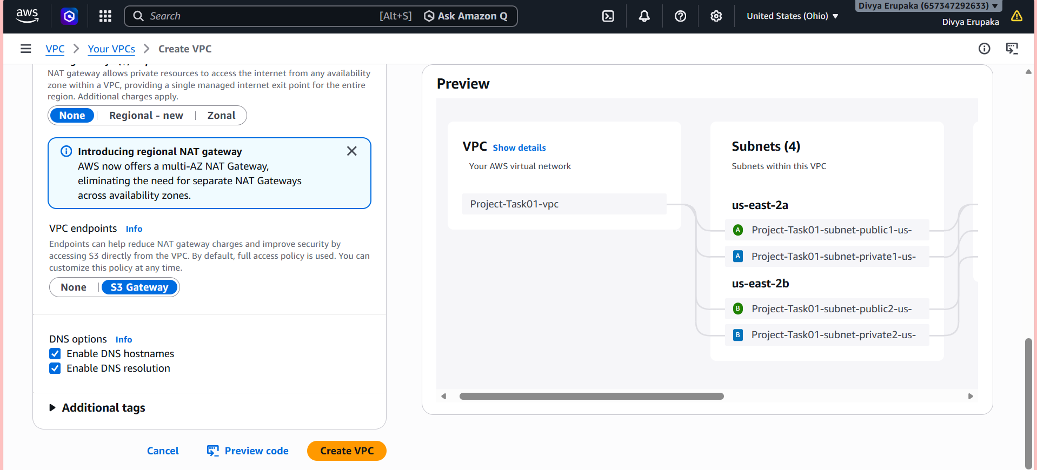
Validation Steps
After creation, validate all networking resources.
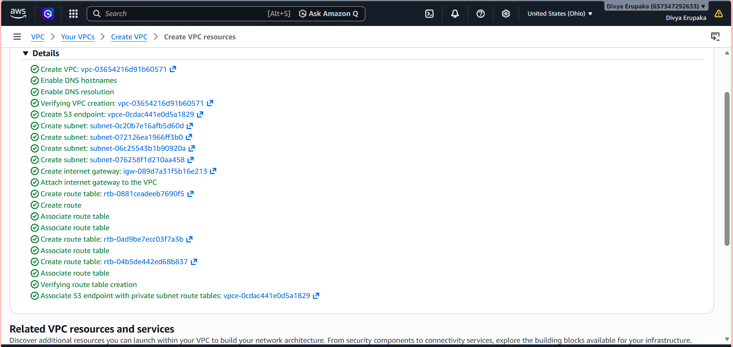
Validation 1: Verify VPC
Navigate to:
VPC → Your VPCs
Verify:
- VPC status is Available
- CIDR block is correct
- DNS settings are enabled
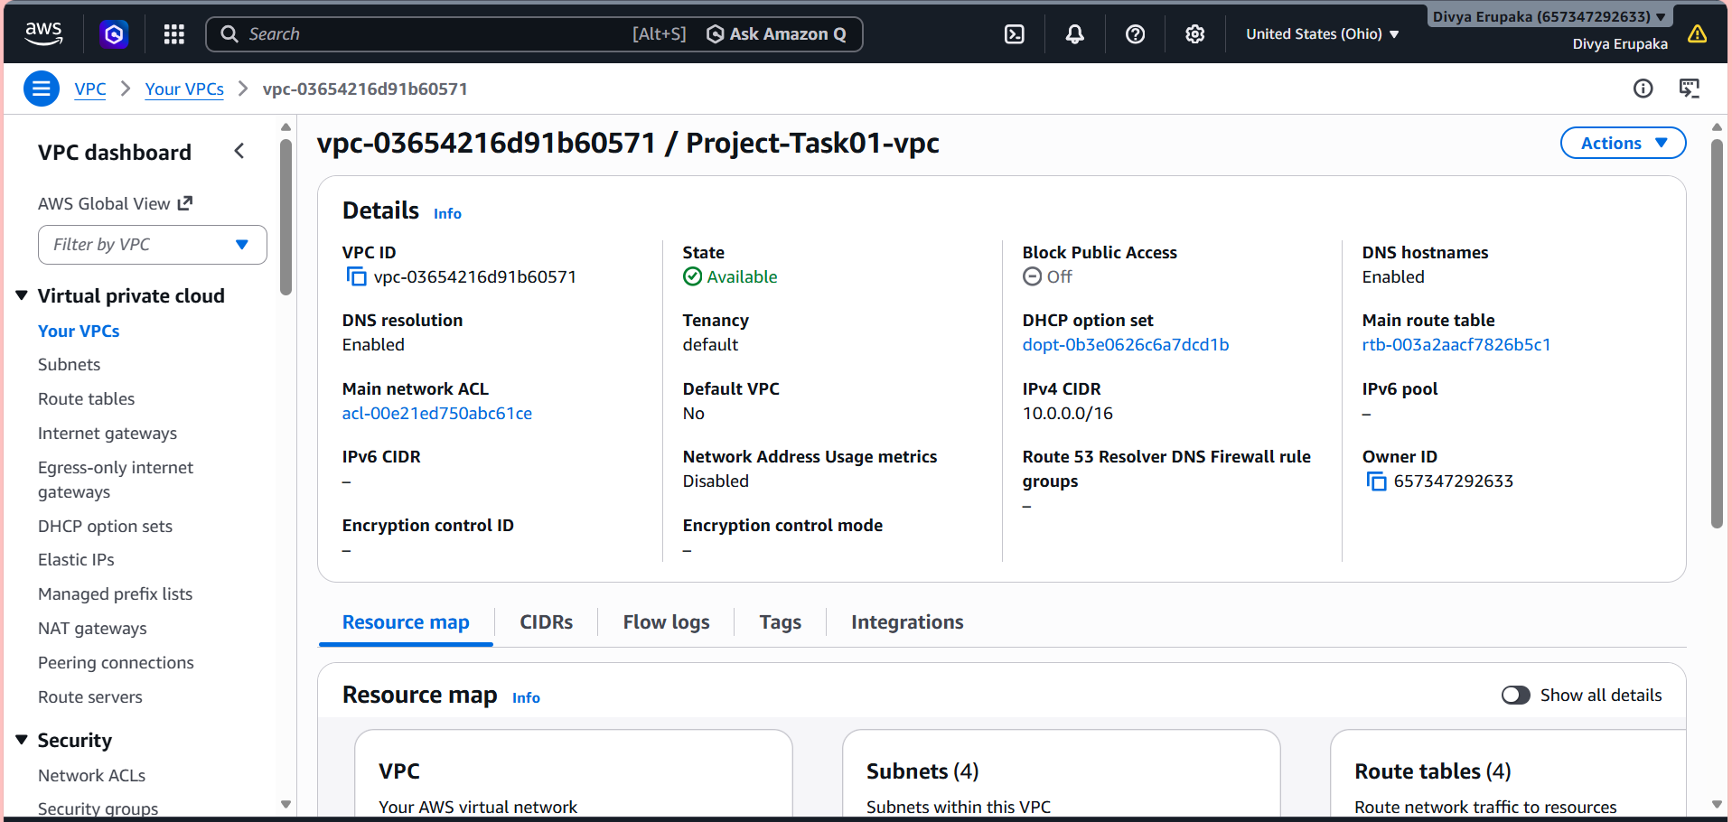
Validation 2: Verify Subnets
Navigate to:
VPC → Subnets
Verify:
- 2 Public Subnets created
- 2 Private Subnets created
- Correct Availability Zones assigned
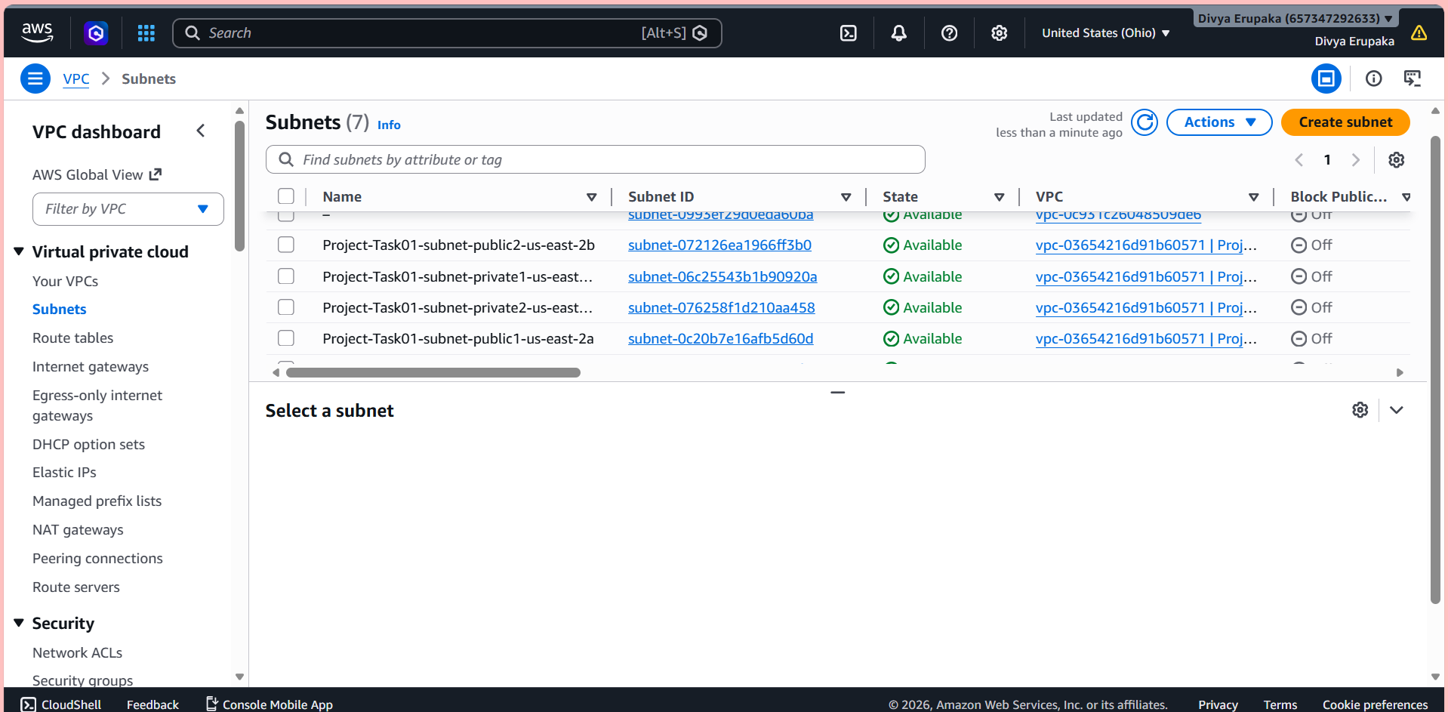
- Enable DNS Hostname in VPC.
Objective: Enable DNS hostnames for the VPC in Amazon VPC so that EC2 instances launched in the VPC can receive public DNS names.
This is required for:
- Internet-accessible EC2 instances
- Public DNS resolution
- Web applications
- SSH connectivity using DNS names
Prerequisites
Before starting, ensure:
- AWS account access available
- VPC already created
- Required IAM permissions available
Required permissions:
- VPC Read/Write access
Steps to Enable DNS Hostnames
Step 1: Login to AWS Console
- Open AWS Management Console
- Navigate to:
Services → VPC
Step 2: Open Your VPCs
- In the left navigation pane, click:
Your VPCs
- Select your VPC
Step 3: Edit VPC Settings
- Select the VPC
- Click:
Actions → Edit VPC settings
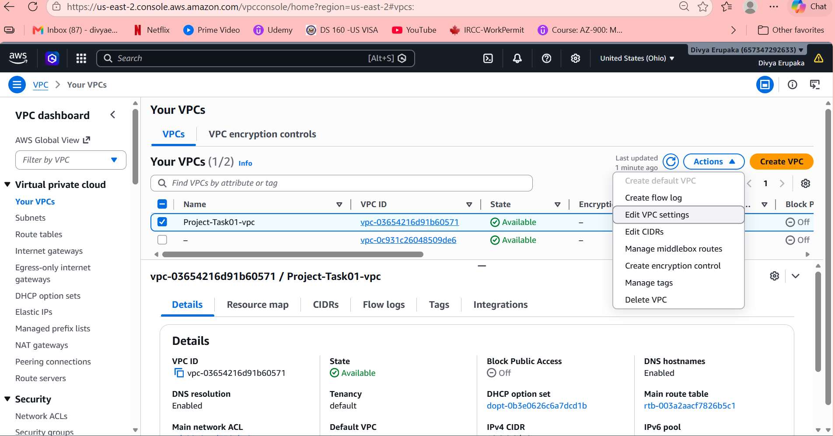
Step 4: Enable DNS Hostnames
Under VPC settings:
Enable: Enable DNS hostnames
Also ensure: Enable DNS resolution is enabled.
Step 5: Save Changes
Click:
Save
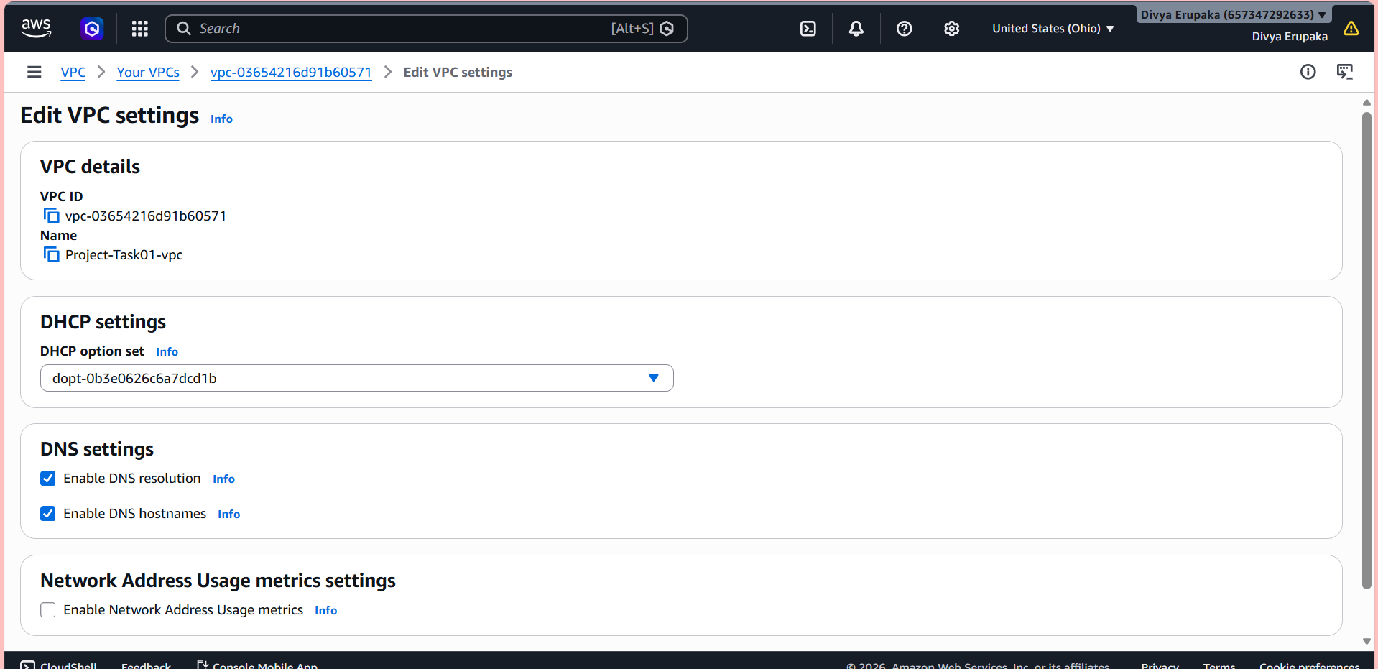
Validation
After saving:
- Open VPC details
- Verify:
Setting | Expected Value
DNS Resolution | Enabled
DNS Hostnames | Enabled
Expected Outcome
After enabling DNS hostnames:
- EC2 instances in public subnets receive public DNS names
- DNS resolution works correctly
- Applications can use domain-based communication
Example public DNS:
ec2-xx-xx-xx-xx.us-east-2.compute.amazonaws.com
Why This Setting Is Important
DNS Resolution
Allows instances to resolve domain names.
Example:
ping google.com
- Enable Auto Assign Public IP in 2 public subnets.
Objective: Enable the Auto-assign public IPv4 address setting for the two public subnets in Amazon VPC.
This ensures that EC2 instances launched in the public subnets automatically receive public IP addresses for internet access.
Prerequisites
Before starting, ensure:
- VPC is already created
- Two public subnets are available
- Internet Gateway is attached to the VPC
- Public route table is configured
Example public subnets:
- public-subnet-1
- public-subnet-2
Steps to Enable Auto-Assign Public IP
Step 1: Login to AWS Console
- Open AWS Management Console
- Navigate to:
Services → VPC
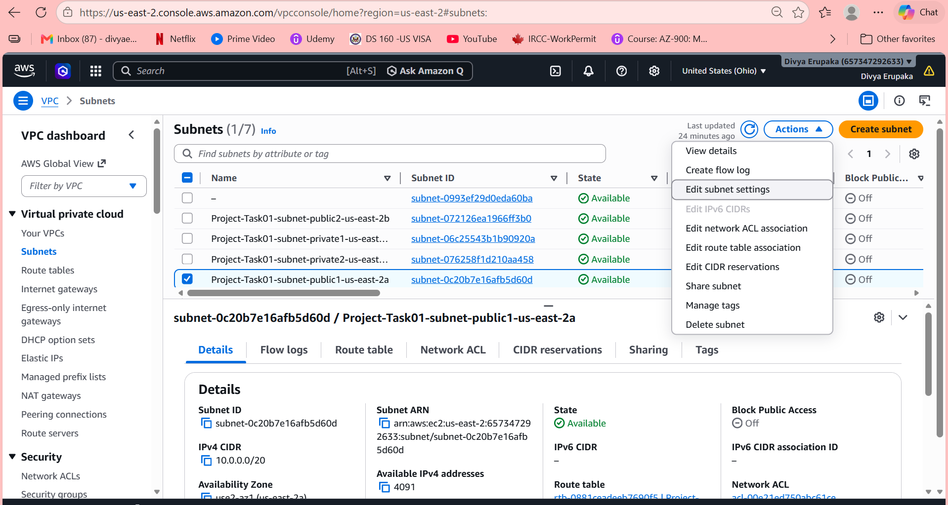
Step 2: Open Subnets
- In the left navigation pane, click:
Subnets
- Locate the public subnets:
- public-subnet-1
- public-subnet-2
Step 3: Enable Auto-Assign Public IP for Public Subnet 1
- Select:
public-subnet-1
- Click:
Actions → Edit subnet settings
- Under Auto-assign IP settings:
Enable:
Auto-assign public IPv4 address
- Click:
Save
Step 4: Enable Auto-Assign Public IP for Public Subnet 2
- Select:
public-subnet-2
- Click:
Actions → Edit subnet settings
- Enable:
Auto-assign public IPv4 address
- Save changes
Validation
After configuration:
- Open subnet details
- Verify:
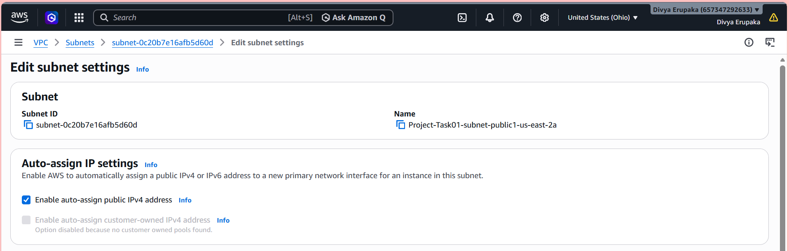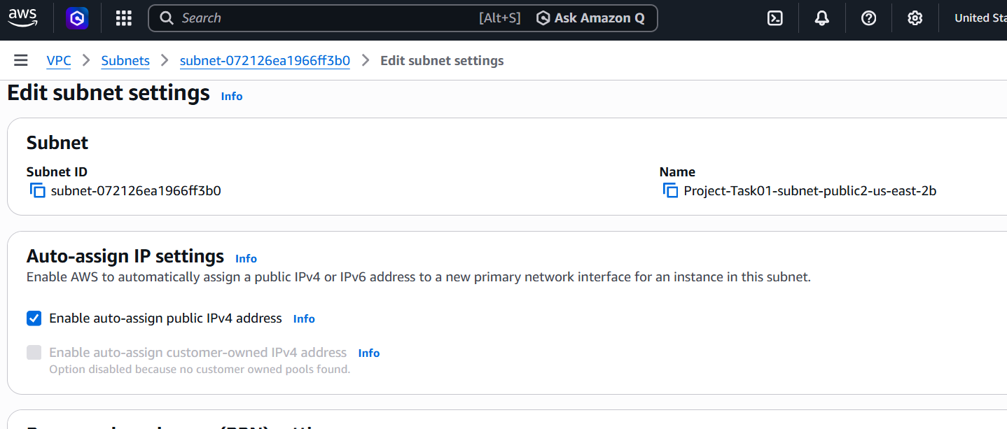
Subnet | Auto-Assign Public IP
public-subnet-1 | Enabled
public-subnet-2 | Enabled
Expected Outcome
After enabling this setting:
- EC2 instances launched in public subnets automatically receive public IP addresses
- Instances can access the internet through the Internet Gateway
- SSH and web access become possible from the internet
Example:
Public EC2 Instance
↓
Gets Public IP Automatically
↓
Accessible Through Internet
Why This Setting Is Important
Public subnets are designed for internet-facing resources such as:
- Web servers
- Bastion hosts
- Load balancers
- NAT Gateways
Without enabling Auto-assign Public IP:
- EC2 instances may launch without public IPs
- Internet access may fail
- SSH connectivity may not work
- Add 2 private subnet in the private route table.
Objective: Associate private subnets with the private route tables.
In your setup:
Private Route Table | Subnet
Project-Task01-rtb-private1-us-east-2a | Private subnet in us-east-2a
Project-Task01-rtb-private2-us-east-2b | Private subnet in us-east-2b
Step 1: Login to AWS Console
- Open AWS Management Console
- Navigate to:
Services → VPC
Step 2: Open Route Tables
- In the left navigation pane, click:
Route tables
You will see:
- 1 Public Route Table
- 2 Private Route Tables
Step 3: Select First Private Route Table
Select:
Project-Task01-rtb-private1-us-east-2a
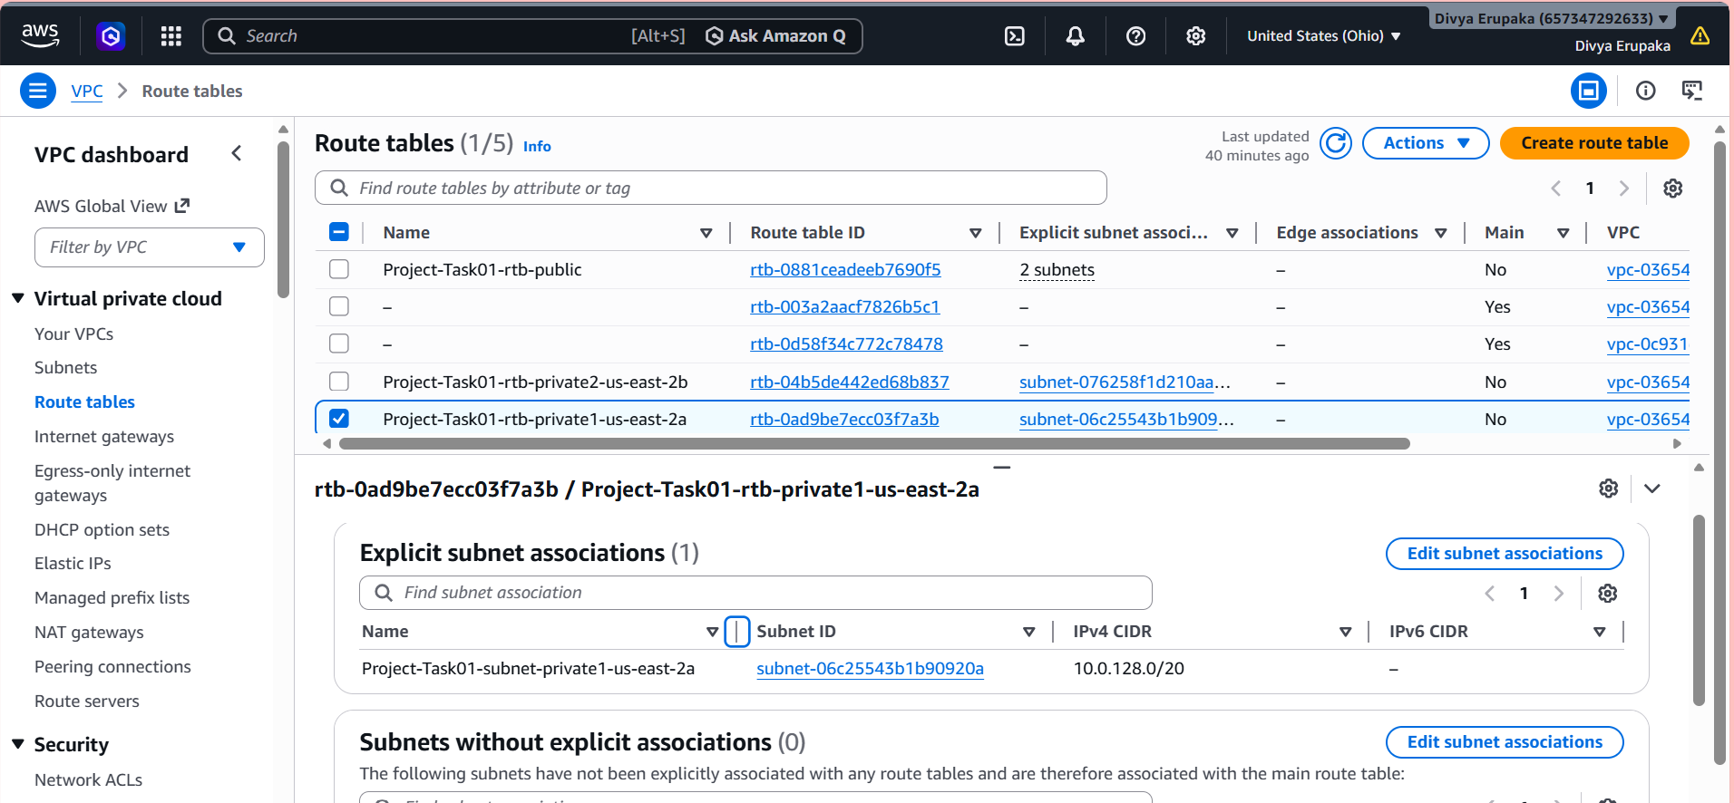
Step 4: Open Subnet Associations
- Scroll down
- Open:
Subnet Associations
tab
- Click:
Edit subnet associations
Step 5: Associate Private Subnet in us-east-2a
Select the subnet:
Private subnet in us-east-2a
Example:
- subnet-xxxxxx
Click:
Save associations
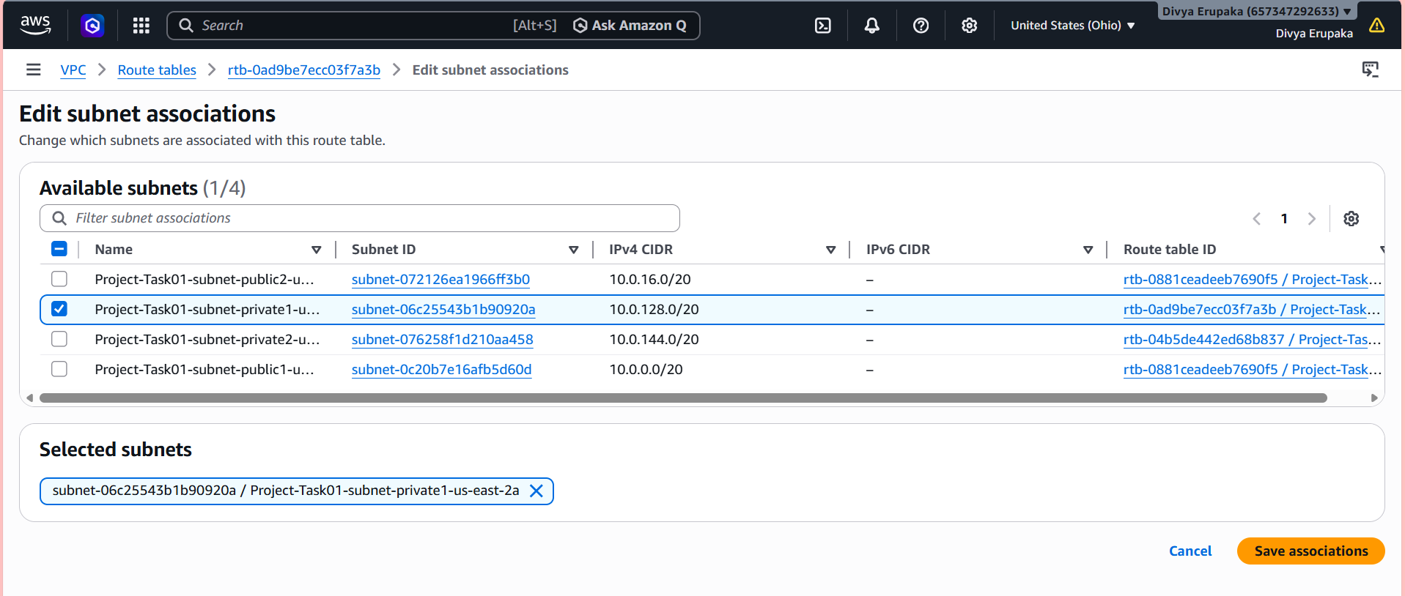
Step 6: Select Second Private Route Table
Now select:
Project-Task01-rtb-private2-us-east-2b
Step 7: Open Subnet Associations
- Open:
Subnet Associations
- Click:
Edit subnet associations
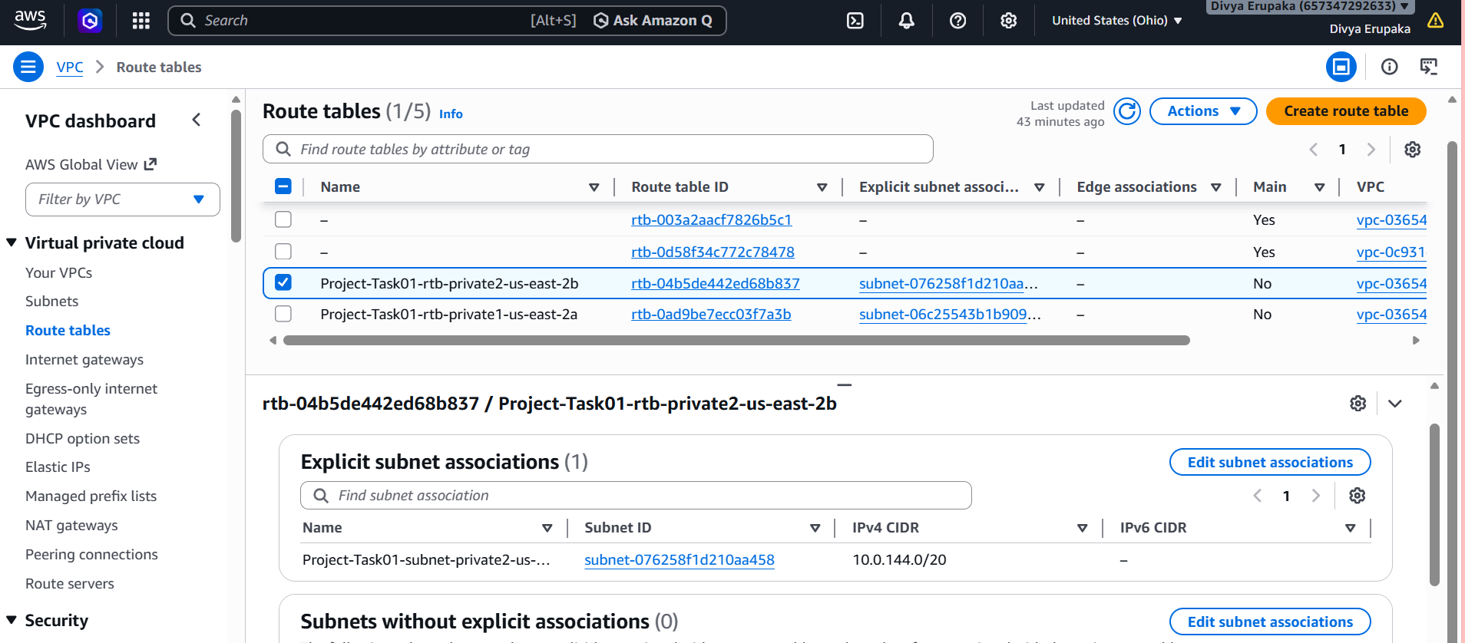
Step 8: Associate Private Subnet in us-east-2b
Select the subnet:
Private subnet in us-east-2b
Click: Save associations
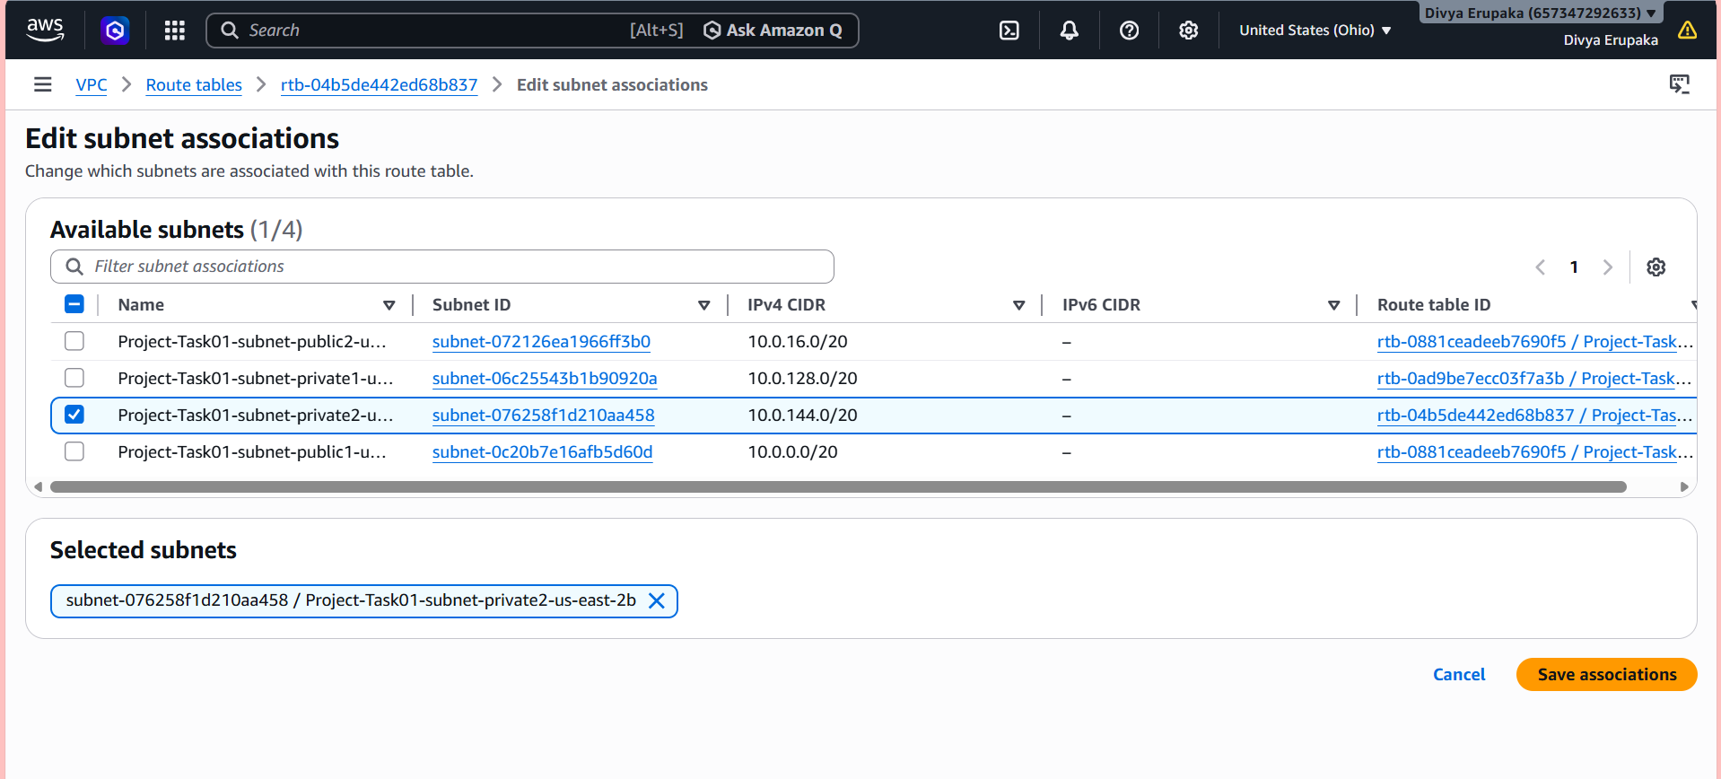
Validation
After saving:
Verify:
Route Table | Associated Subnet
Project-Task01-rtb-private1-us-east-2a | Private subnet us-east-2a
Project-Task01-rtb-private2-us-east-2b | Private subnet us-east-2b
Important Note
You should NOT associate both private subnets with the same route table because AWS created:
- One private route table per Availability Zone
This is:
- High availability design
- AWS production best practice

- Add 2 public subnets in public route table.
Objective
Associate both public subnets with the public route table in Amazon VPC.
This configuration allows resources in the public subnets to access the internet through the Internet Gateway.
Prerequisites
Before starting, ensure the following resources already exist:
- Custom VPC
- 2 Public Subnets
- Public Route Table
- Internet Gateway attached to VPC
Example resources:
- Project-Task01-rtb-public
- Public subnet in us-east-2a
- Public subnet in us-east-2b
Step-by-Step Procedure
Step 1: Login to AWS Console
- Open AWS Management Console
- Navigate to:
Services → VPC
Step 2: Open Route Tables
- In the left navigation pane, click:
Route tables
- Locate and select:
Project-Task01-rtb-public
This is the public route table created automatically by AWS.
Step 3: Open Subnet Associations
- Scroll down in the route table details section
- Open the tab:
Subnet Associations
- Click:
Edit subnet associations
Step 4: Select Public Subnets
Select both public subnets:
- Public subnet in us-east-2a
- Public subnet in us-east-2b
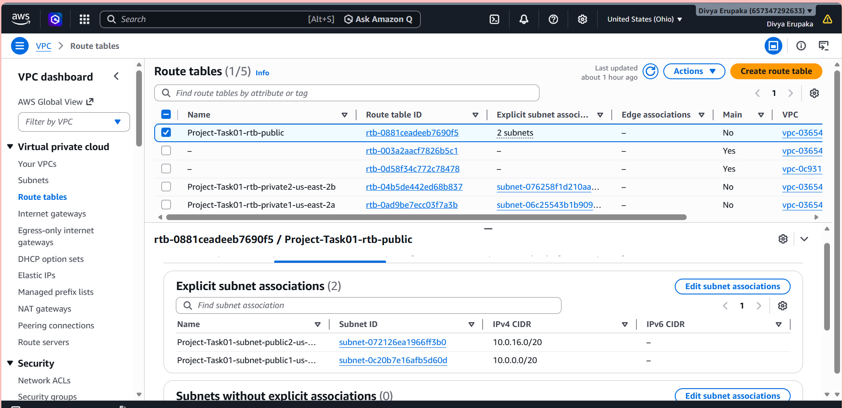
Example subnet names:
public-subnet-1
public-subnet-2
Step 5: Save Associations
Click:
Save associations
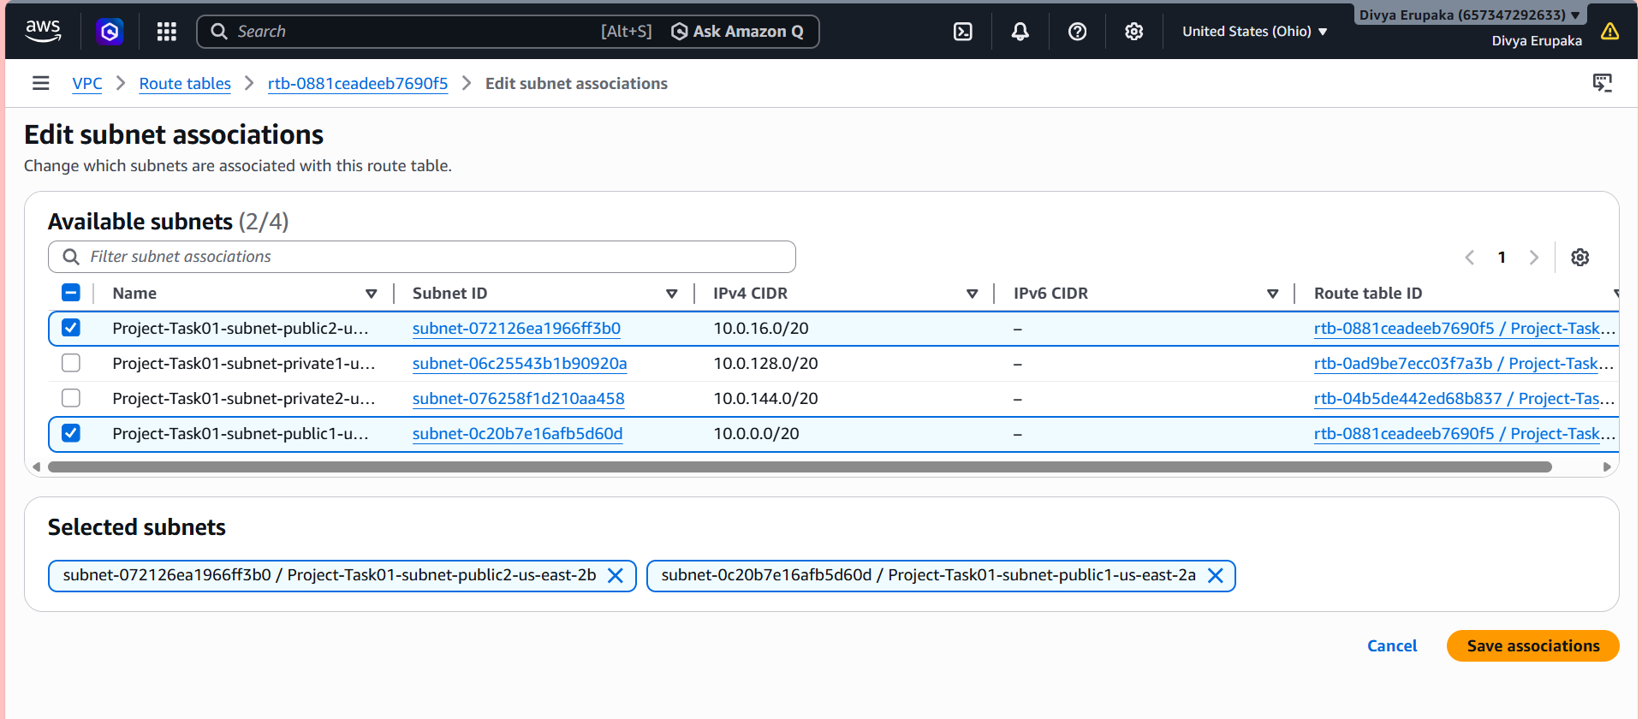
Validation
After saving:
- Open:
Subnet Associations
- Verify both public subnets are listed.
Expected result:
Route Table | Associated Subnets
Project-Task01-rtb-public | Public subnet us-east-2a
Project-Task01-rtb-public | Public subnet us-east-2b

- Public route table will have the routes to internet and local.
Objective: Configure the public route table in Amazon VPC with:
- Local route
- Internet route
This enables:
- Internal communication within the VPC
- Internet access for public subnets
Prerequisites
Before starting, ensure the following resources are available:
- Custom VPC
- Public Route Table
- Internet Gateway attached to VPC
- Public subnets associated with the public route table
Example:
Project-Task01-rtb-public
Understanding Required Routes
The public route table should contain two routes:
Destination | Target | Purpose
VPC CIDR (10.0.0.0/16) | local | Internal VPC communication
0.0.0.0/0 | Internet Gateway | Internet access

Step-by-Step Procedure
Step 1: Login to AWS Console
- Open AWS Management Console
- Navigate to:
Services → VPC
Step 2: Open Route Tables
- In the left navigation pane, click:
Route tables
- Select the public route table:
Project-Task01-rtb-public
Step 3: Open Routes Tab
- Scroll down
- Open:
Routes
tab
You will see existing routes.
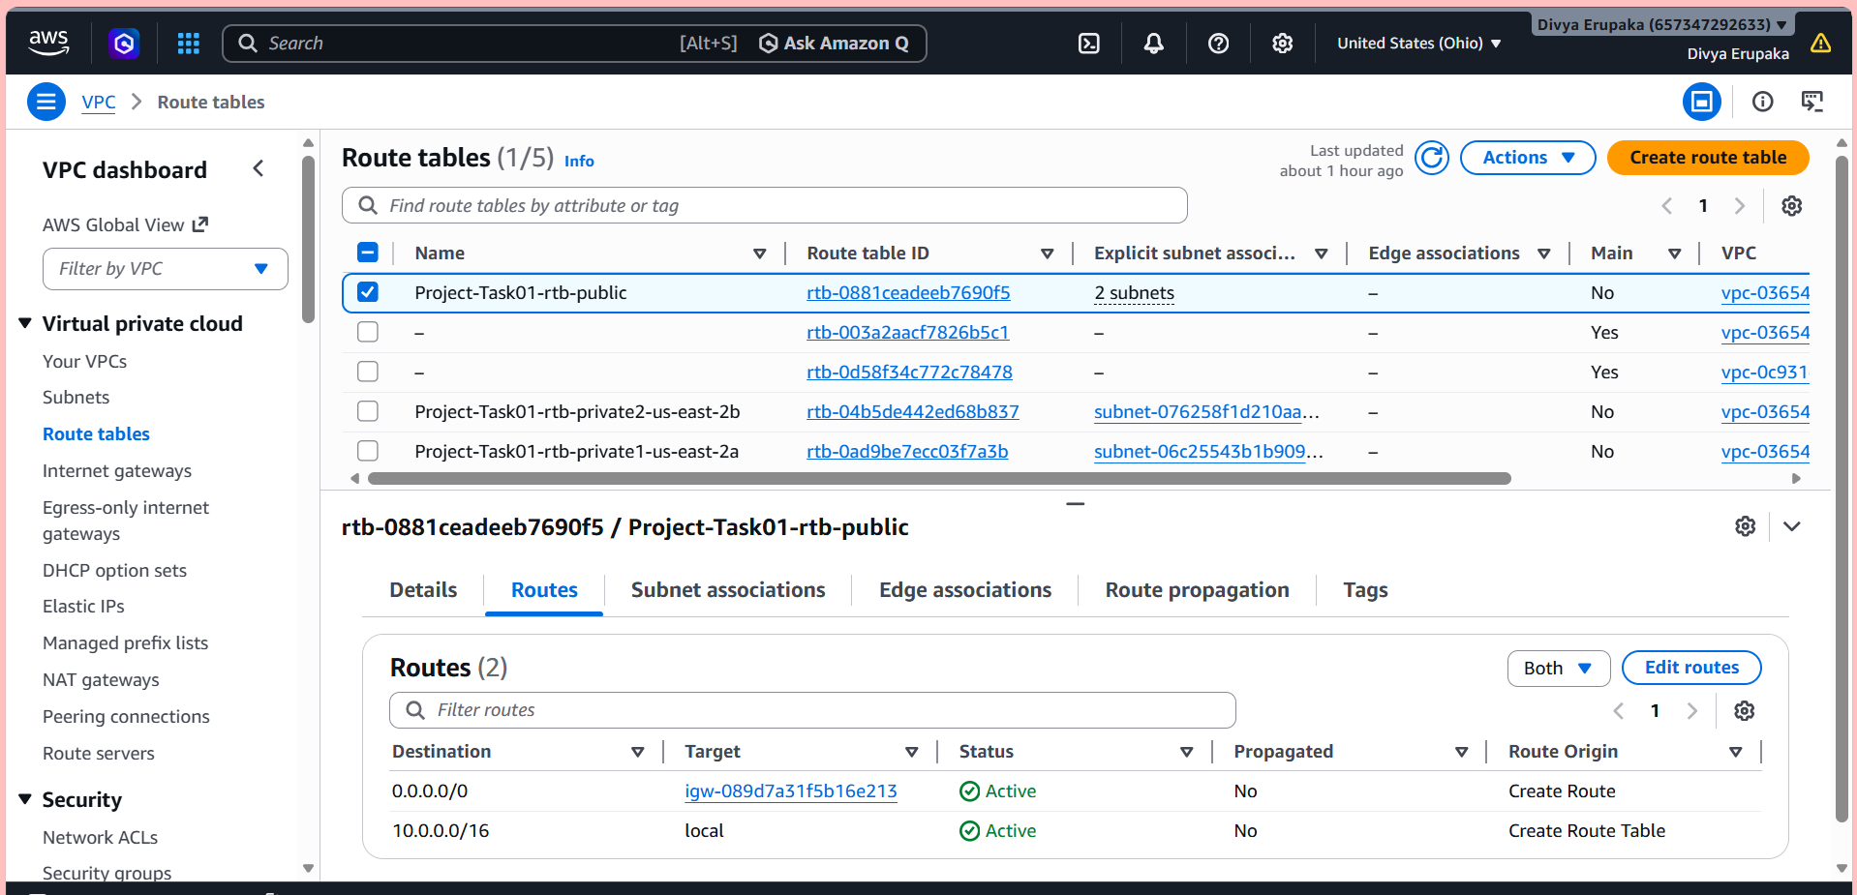
Step 4: Verify Local Route
AWS automatically creates the local route.
Verify:
Destination | Target
10.0.0.0/16 | local
Purpose:
- Allows communication between subnets inside the VPC
Example:
- EC2 in one subnet can communicate with another subnet inside the same VPC
Step 5: Add Internet Route
- Click: Edit routes
- Click: Add route
- Enter:
Setting | Value
Destination | 0.0.0.0/0
Target | Internet Gateway
- Select the attached Internet Gateway
Example:
igw-xxxxxxxx
- Click: Save changes
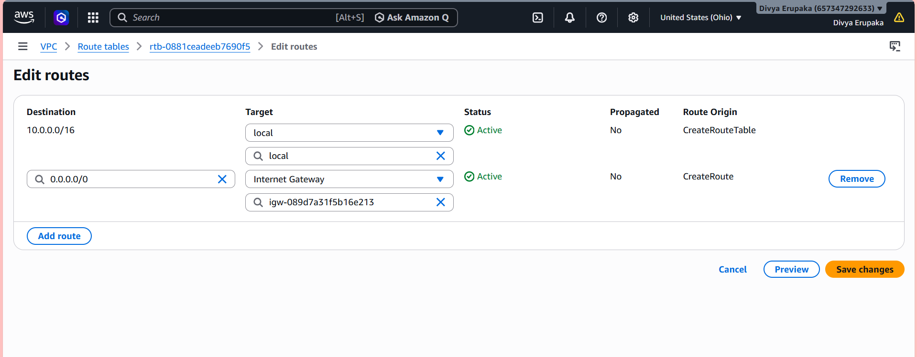

Validation
After saving, verify the public route table contains:
Destination | Target
10.0.0.0/16 | local
0.0.0.0/0 | Internet Gateway
Example:
10.0.0.0/16 → local
0.0.0.0/0 → igw-xxxxxxxx
Expected Outcome
After successful configuration:
- Public subnets can communicate internally within the VPC
- Public subnets can access the internet
- EC2 instances in public subnets become internet accessible
Why These Routes Are Important
Local Route
Purpose:
- Internal VPC communication
Without this:
- Subnets inside the VPC cannot communicate
Internet Route
Purpose:
- Allows outbound internet traffic
Without this:
- Public EC2 instances cannot access internet
- Web servers become unreachable
- Create EC2 in public subnet with t2.micro and install PHP.
Objective
Launch an EC2 instance in the public subnet of the VPC using a t2.micro instance type and install PHP on the server in Amazon Web Services.
This setup allows the EC2 instance to function as a basic PHP web server.
Prerequisites
Before starting, ensure the following resources are already created:
- Custom VPC
- Public subnet
- Internet Gateway
- Public route table
- Auto-assign public IP enabled for public subnet
- Security Group allowing SSH and HTTP access
Required Configuration
Component | Value
Instance Type | t3.micro
Operating System | Amazon Linux 2023
Subnet | Public Subnet
Public IP | Enabled
Step-by-Step Procedure
Step 1: Login to AWS Console
- Open AWS Management Console
- Navigate to:
Services → EC2
Step 2: Launch EC2 Instance
- Click: Launch Instance
Step 3: Configure Instance Details
Enter the following details:
Setting | Value
Name | php-server
AMI | Amazon Linux 2
Instance Type | t2.micro
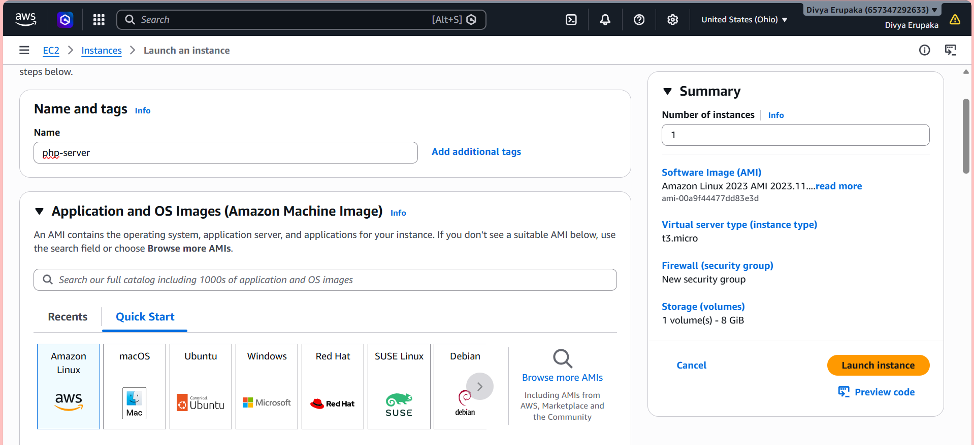Step 4: Select Key Pair
- Choose an existing key pair
OR
- Create a new key pair
Example:
php-keypair
Download and save the .pem file securely.
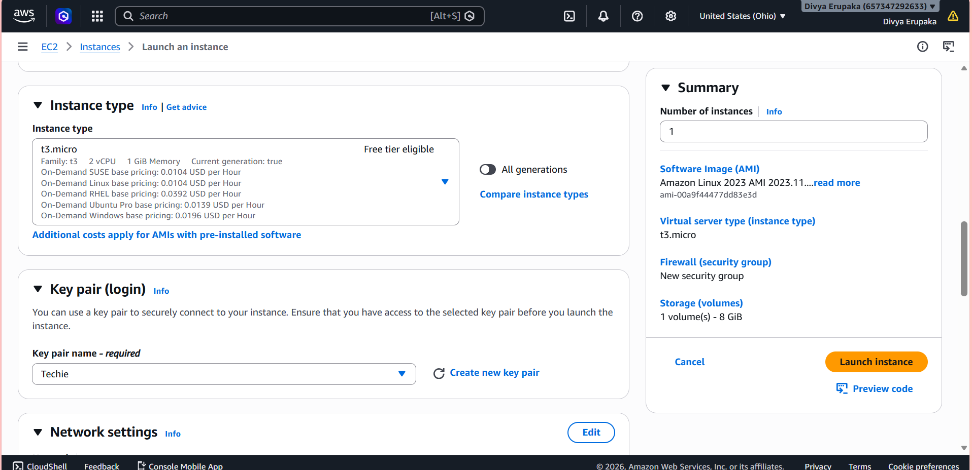
Step 5: Configure Network Settings
Under Network Settings:
Setting | Value
VPC | Your custom VPC
Subnet | Public subnet
Auto-assign Public IP | Enable
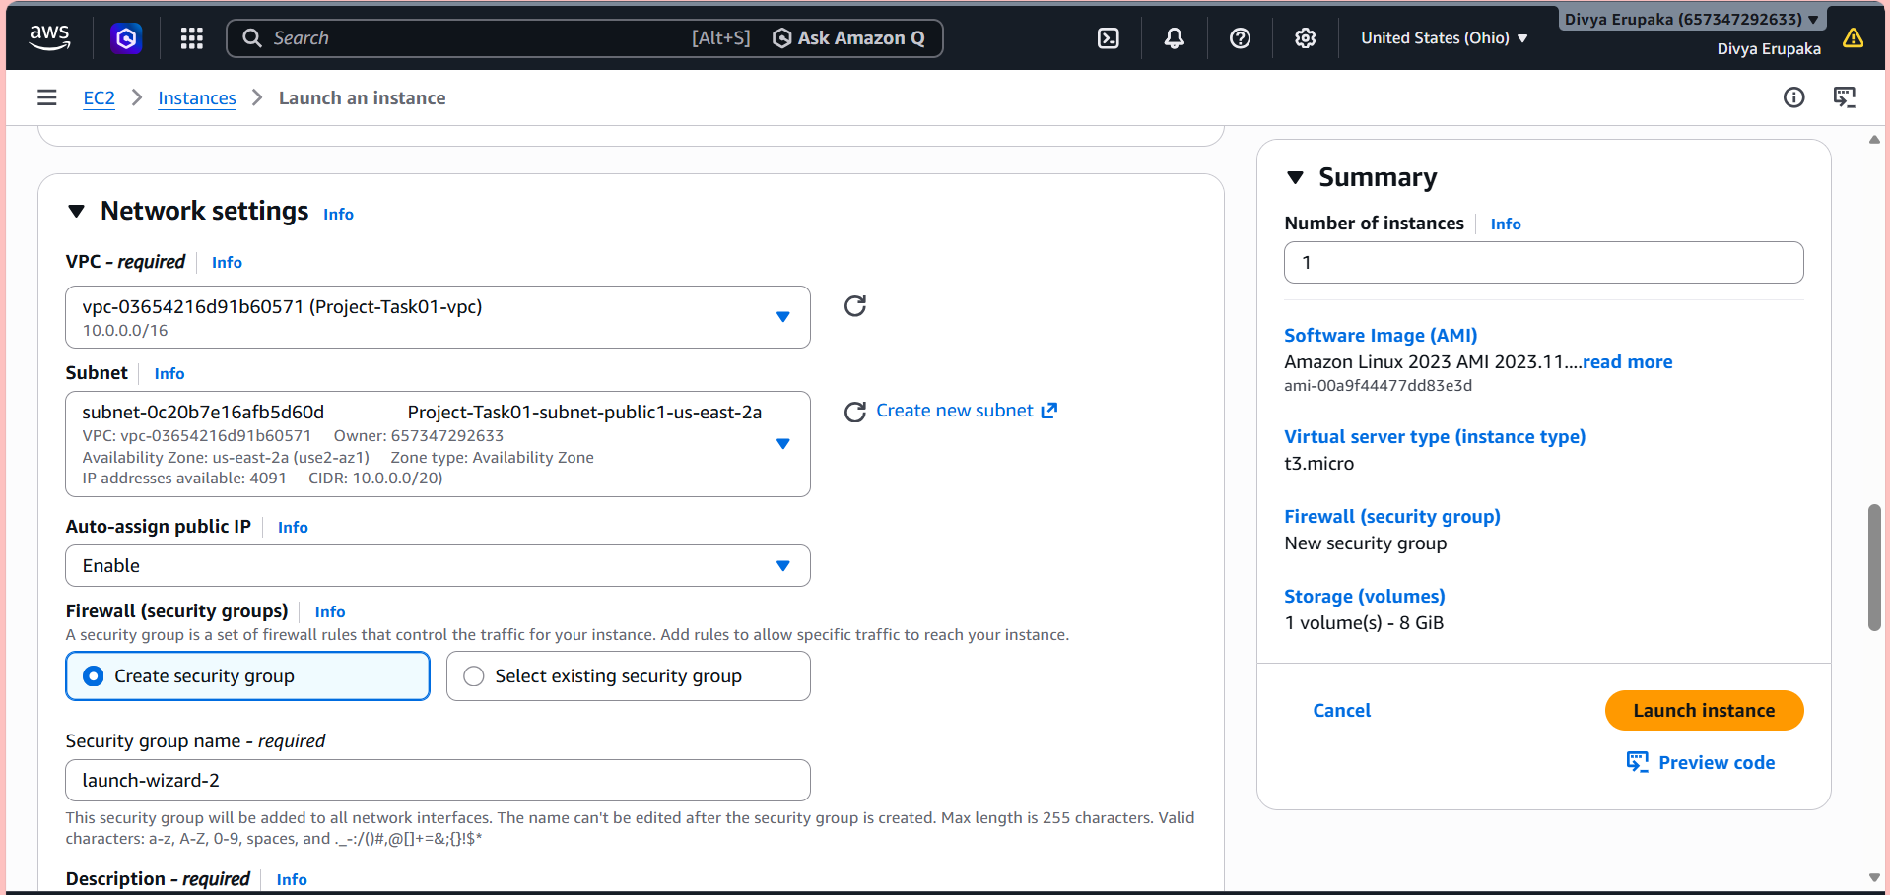Step 6: Configure Security Group
Create or select a Security Group with the following inbound rules:
Type | Port | Source
SSH | 22 | My IP
HTTP | 80 | Anywhere
This allows:
- SSH access
- Web browser access
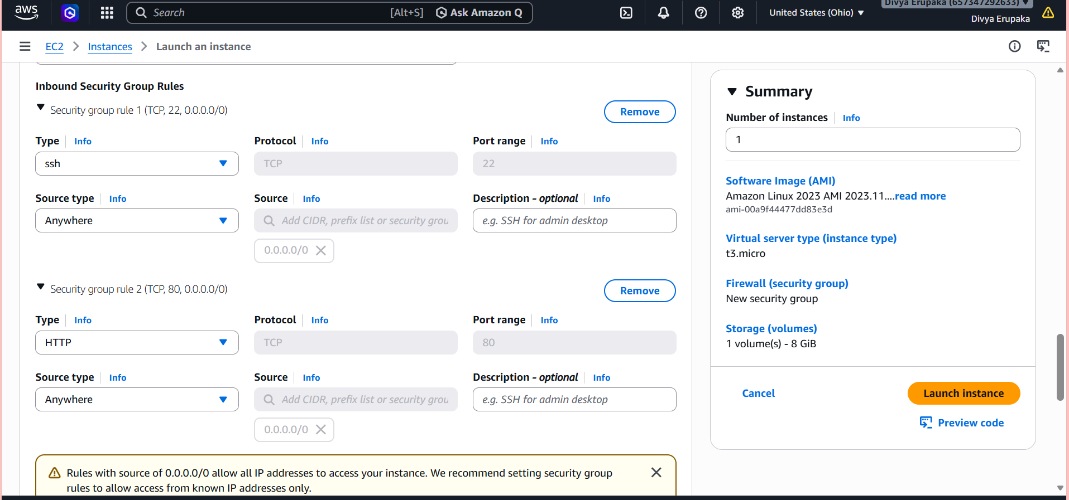
Step 7: Configure Storage
Keep default storage configuration.
Example:
Volume Type | Size
gp2 | 8 GB
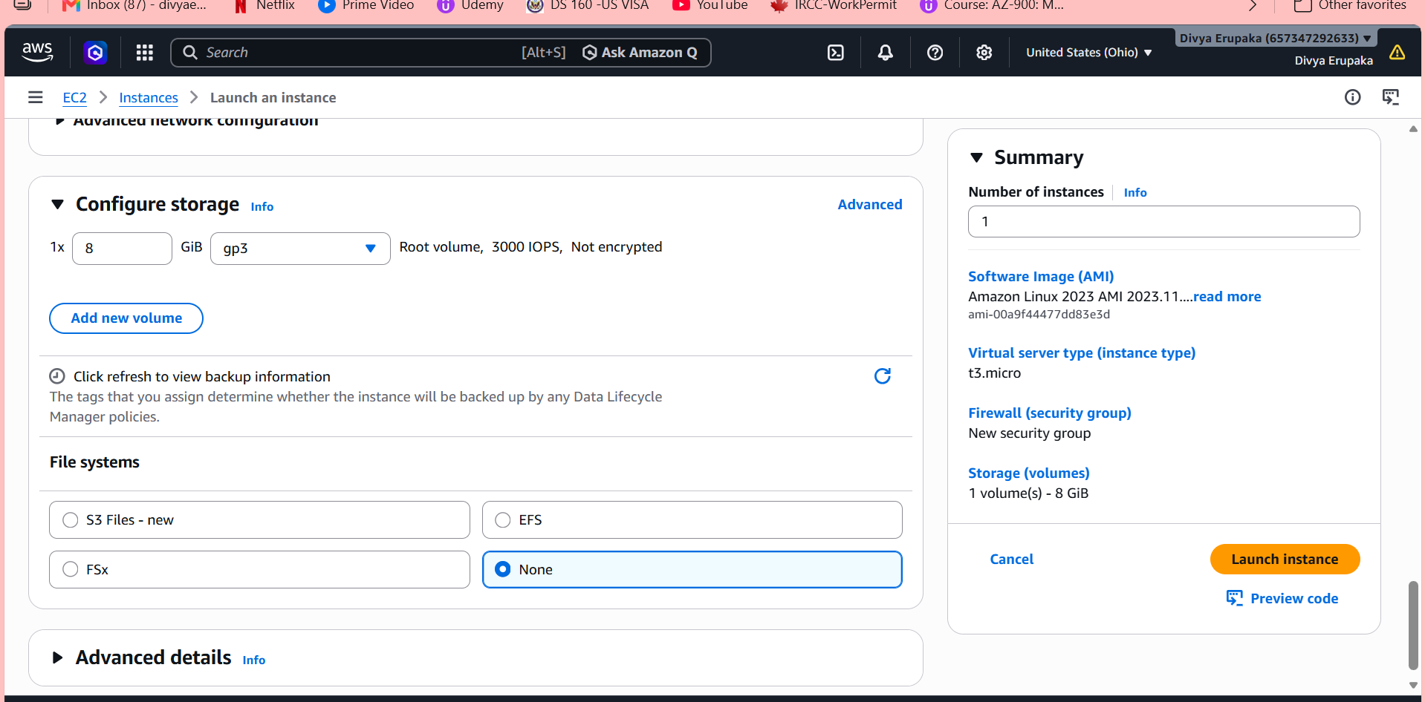
Step 8: Launch Instance
Click:
Launch Instance
Wait until instance state becomes:
Running
Validation
Verify:
Validation | Expected Result
EC2 state | Running
Public IP assigned | Yes
Status checks | 3/3 Passed
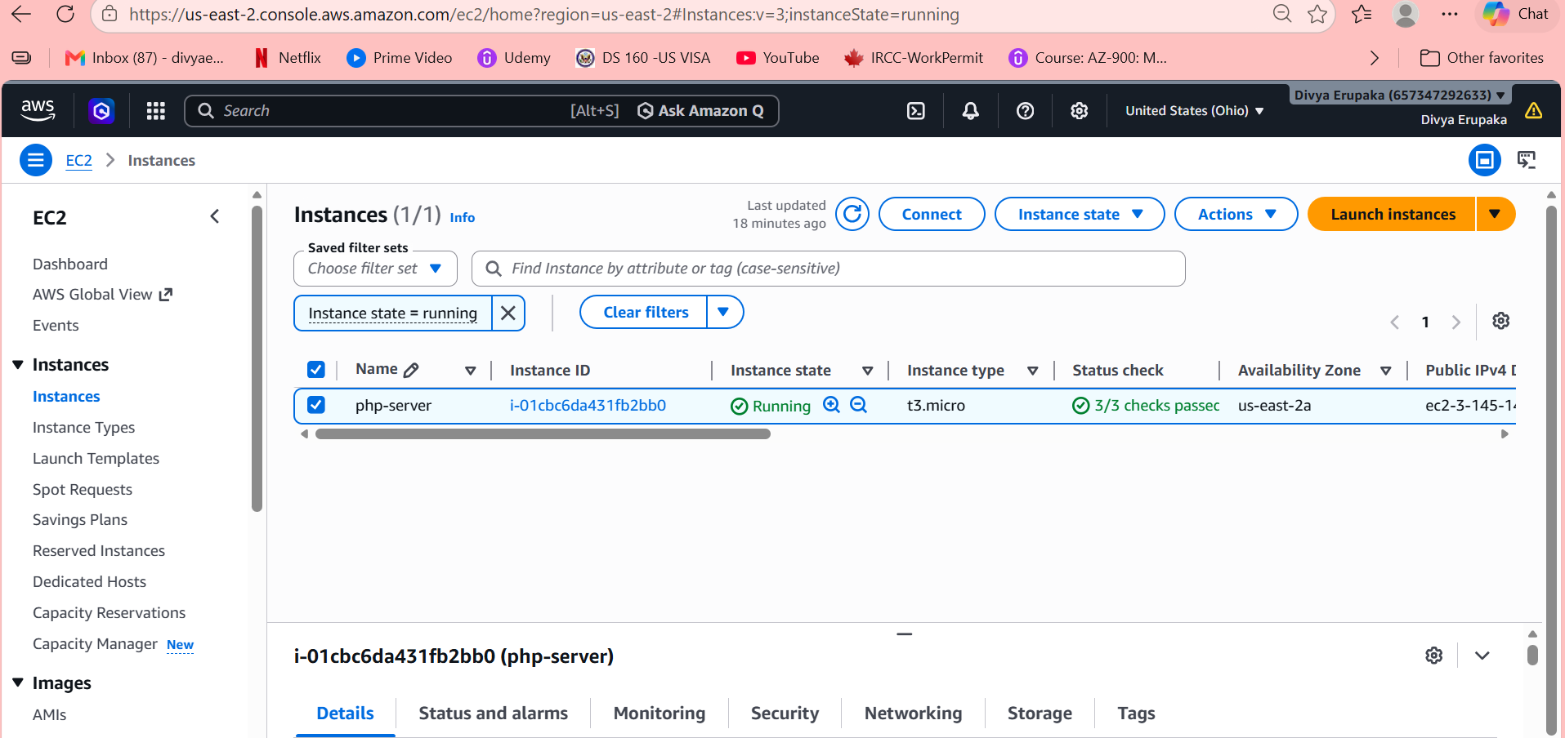
Step 9: Connect to EC2 Instance
Using EC2 Instance Connect
- Select the instance
- Click: Connect
- Open the browser-based terminal
Step 10: Update Packages
Run: sudo yum update -y
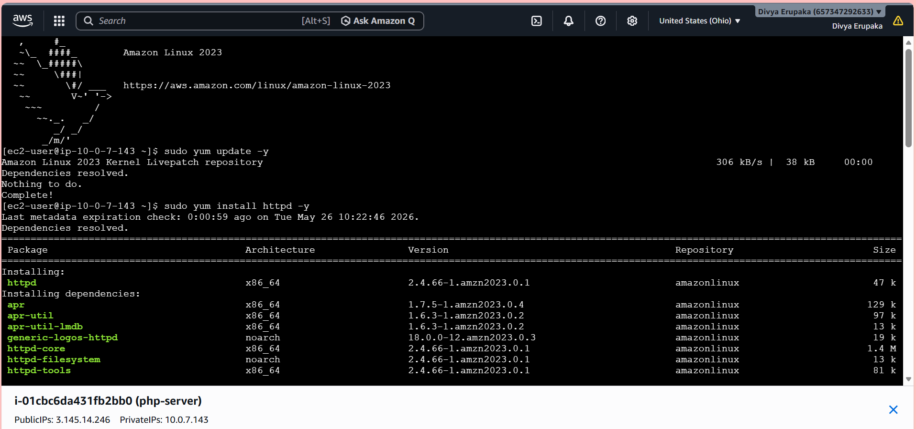
Step 11: Install Apache Web Server
Run:
sudo yum install httpd -y
Start Apache:
sudo systemctl start httpd
Enable Apache on boot:
sudo systemctl enable httpd
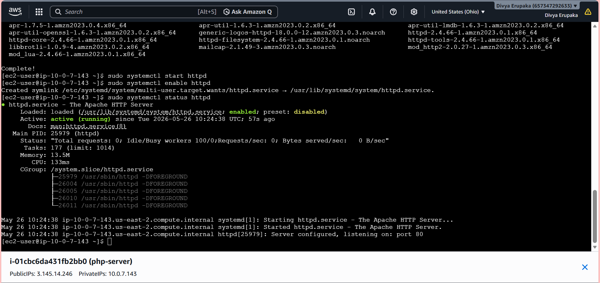
Step 12: Install PHP
Run:
sudo dnf install php php-cli php-mysqlnd -y
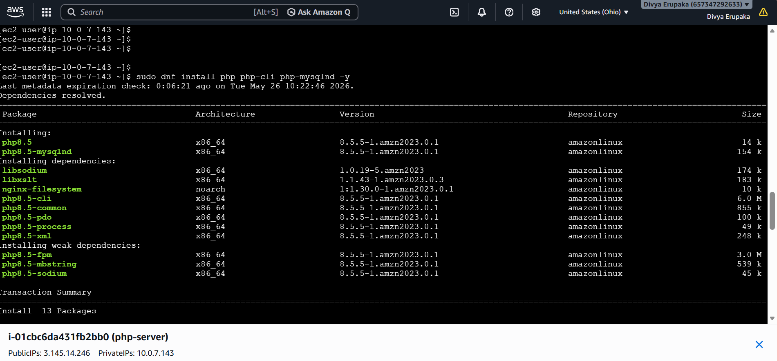Step 13: Verify PHP Installation
Run:
php -v
Expected output:
PHP 8.x.x
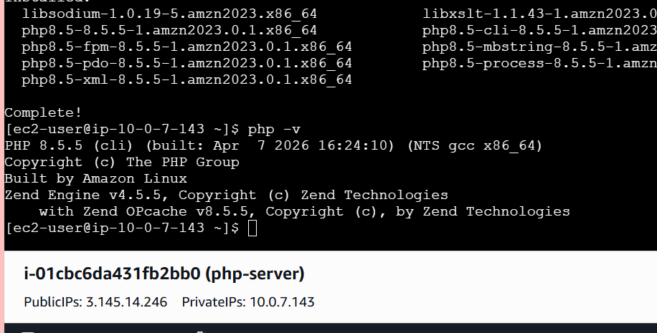
Step 14: Create PHP Test File
Run: echo '<?php phpinfo(); ?>' | sudo tee /var/www/html/info.php
Verify Apache Status
Run: sudo systemctl status httpd
Expected: active (running)
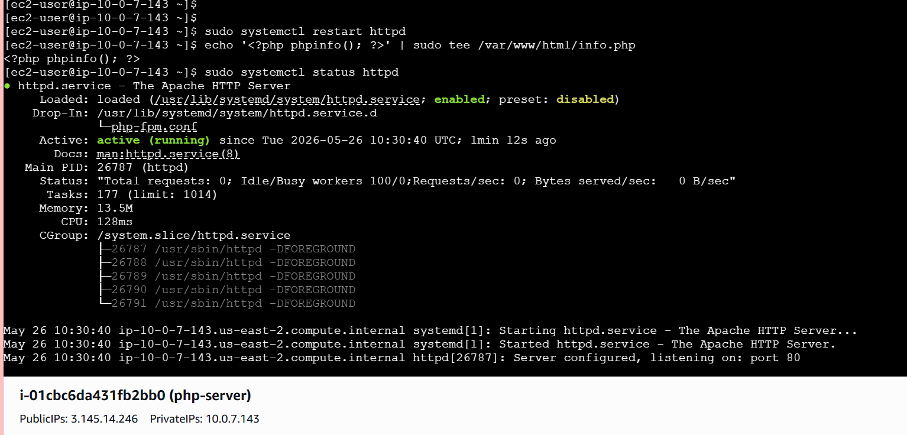
Access PHP Page
Open browser: http://<EC2-Public-IP>/info.php
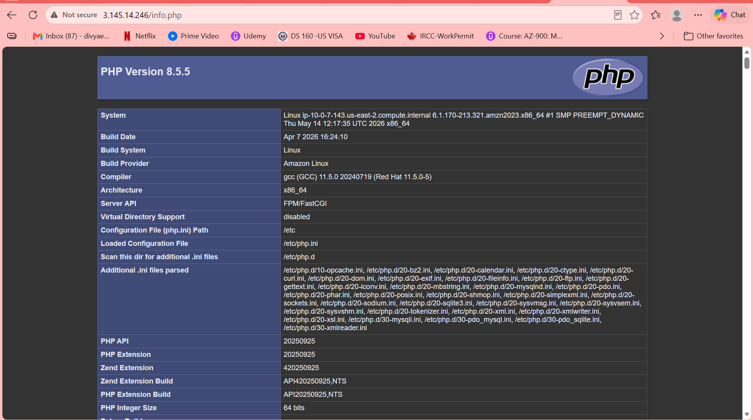
- Configure NAT gateway in public subnet and connect to private instance.
Objective: The objective of this task is to configure a NAT Gateway in the public subnet of the VPC and enable internet access for EC2 instances deployed in private subnets without exposing them directly to the internet.
This setup ensures secure outbound internet communication for private resources while maintaining network isolation in Amazon Web Services.
Expected Outcome
After successful implementation:
- NAT Gateway is created successfully
- Elastic IP is attached to NAT Gateway
- Private route tables route internet traffic through NAT Gateway
- Private EC2 instances can access the internet
- Private EC2 instances remain inaccessible directly from the internet
- Bastion Host allows secure SSH access to private EC2
Prerequisites
Before starting, ensure the following resources already exist:
- Custom VPC
- Public Subnets
- Private Subnets
- Internet Gateway
- Public Route Table
- Private Route Tables
- Public EC2 Instance (Bastion Host)
- Private EC2 Instance

Architecture Diagram
Internet
|
Internet Gateway
|
Public Subnet
/ \
Bastion Host EC2 NAT Gateway
|
Elastic IP
|
Private Route Table
|
Private EC2

Why NAT Gateway Is Required
Private EC2 instances do not have public IP addresses and cannot access the internet directly.
However, they require internet connectivity for:
- Package installation
- System updates
- Downloading software
- Accessing repositories
NAT Gateway provides:
Private EC2 → Internet
but blocks:
Internet → Private EC2
This ensures secure outbound-only communication.

Step-by-Step Procedure
Step 1: Login to AWS Console
- Open AWS Management Console
- Navigate to:
Services → VPC

Step 2: Allocate Elastic IP
NAT Gateway requires an Elastic IP for internet communication.
- In the left navigation pane, click:
Elastic IPs
- Click:
Allocate Elastic IP address
- Click: Allocate
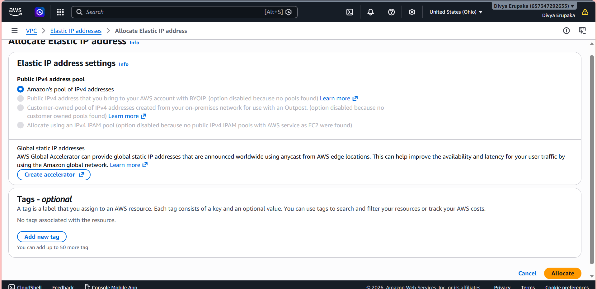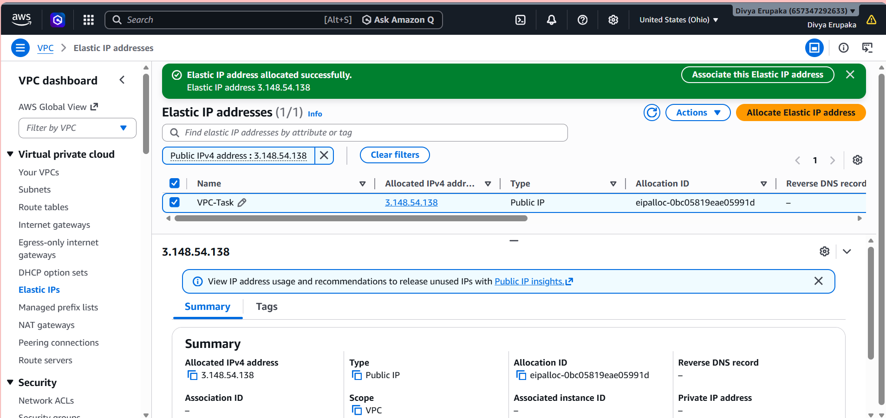
Step 3: Create NAT Gateway
- Navigate to:
NAT Gateways
- Click: Create NAT Gateway
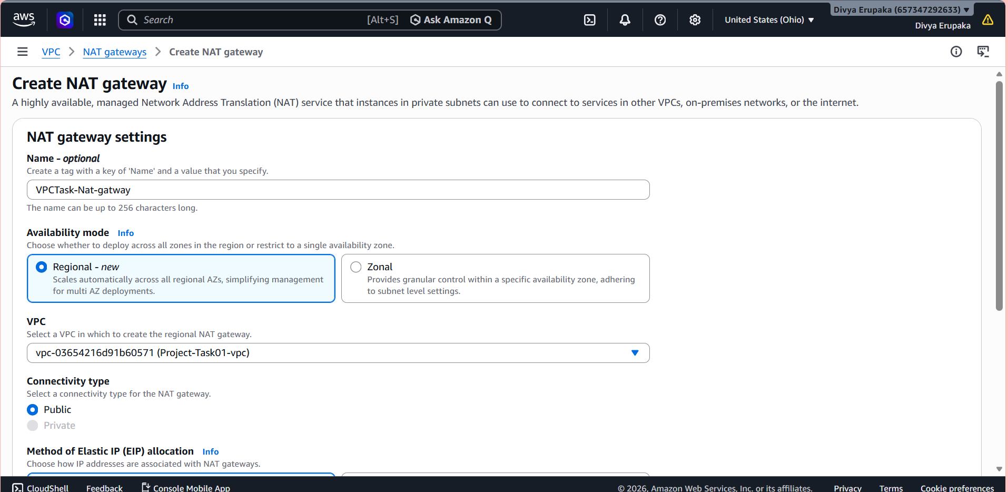
Step 4: Configure NAT Gateway
Enter the following details:
Setting | Value
Name | nat-gateway
Subnet | Public subnet
Connectivity Type | Public
Elastic IP | Select allocated EIP
Important:
- NAT Gateway must be created in a public subnet.
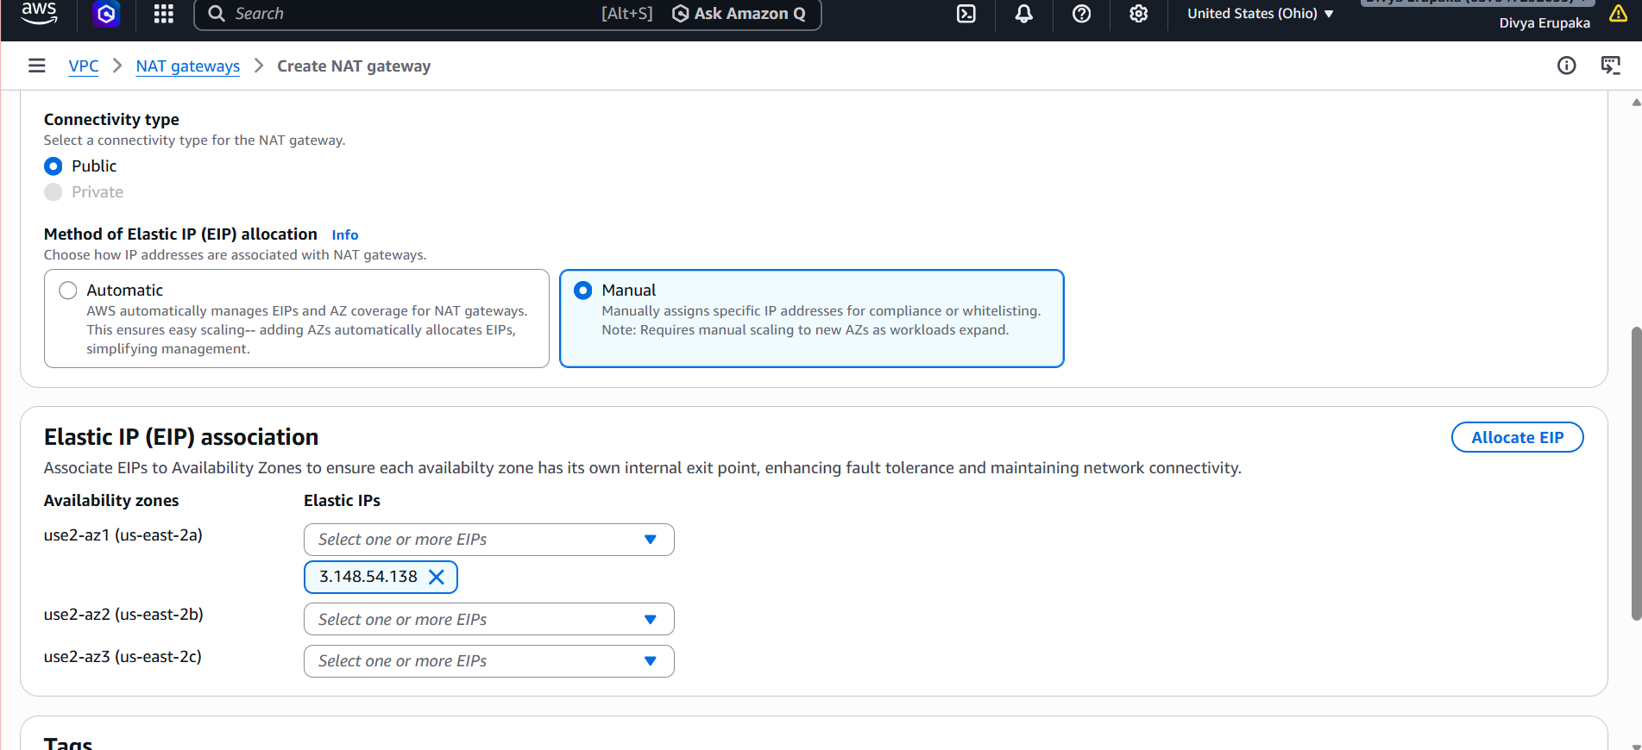
Step 5: Create NAT Gateway
Click: Create NAT Gateway
Wait until status becomes: Available
Validation
Verify:
Validation | Expected Result
NAT Gateway State | Available
Elastic IP Attached | Yes
Public Subnet Selected | Yes
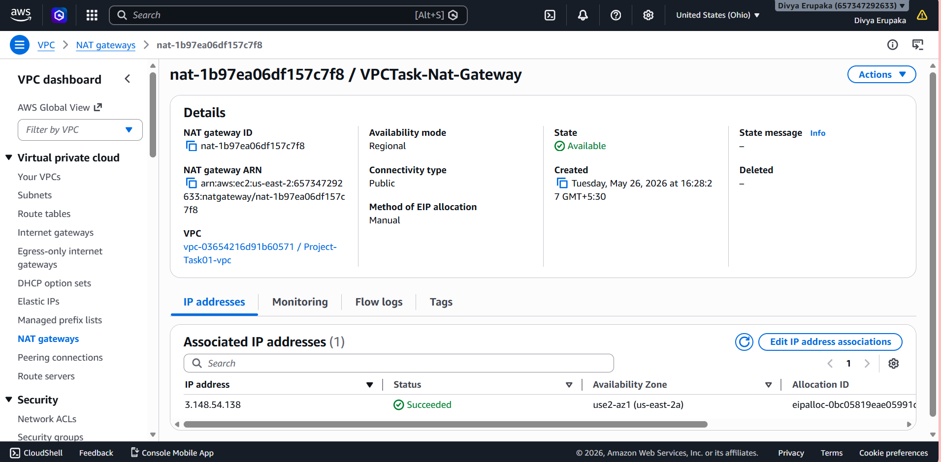
Step 6: Configure Private Route Tables
Private route tables must send internet-bound traffic to the NAT Gateway.
- Navigate to:
Route Tables
- Select the private route table.
Examples:
- Project-Task01-rtb-private1-us-east-2a
- Project-Task01-rtb-private2-us-east-2b
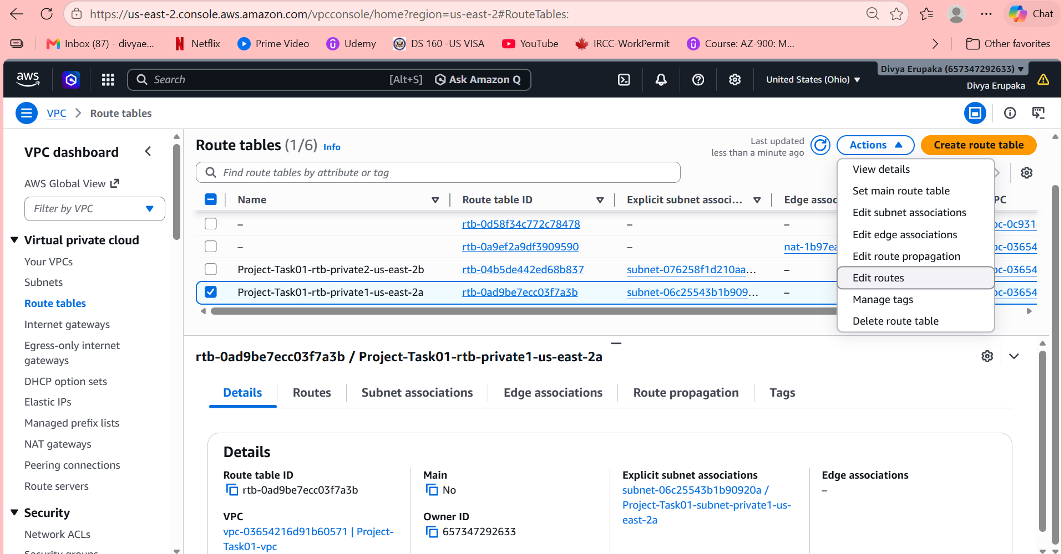
Step 7: Add NAT Gateway Route
- Open: Routes tab
- Click: Edit routes
- Click: Add route
- Configure:
Destination | Target
0.0.0.0/0 | NAT Gateway
- Select the NAT Gateway created earlier.
Example: nat-xxxxxxxx
- Click: Save changes

Step 8: Repeat for Second Private Route Table
Repeat the same route configuration for the second private route table.
Both private route tables should contain:
Destination | Target
10.0.0.0/16 | local
0.0.0.0/0 | NAT Gateway
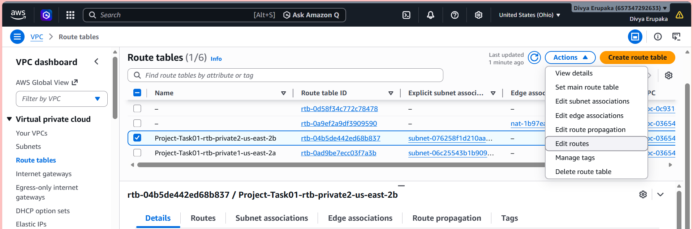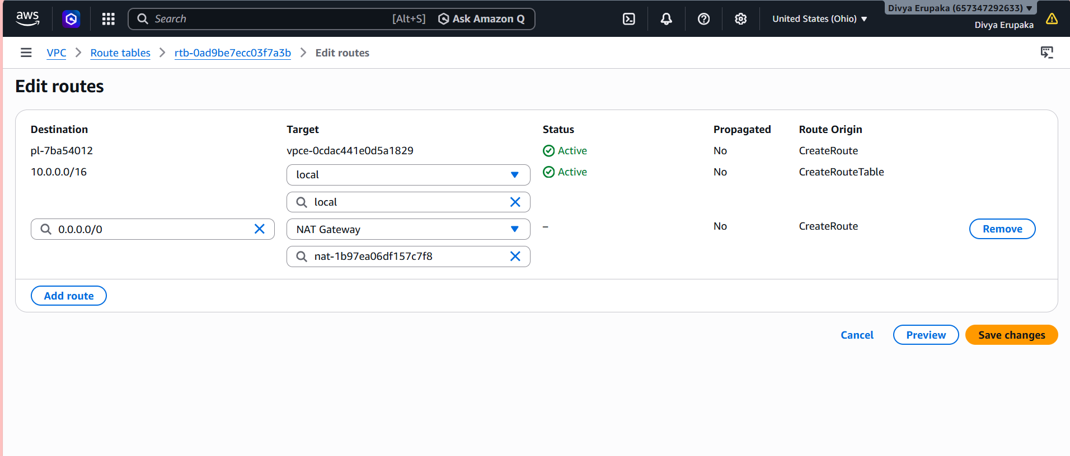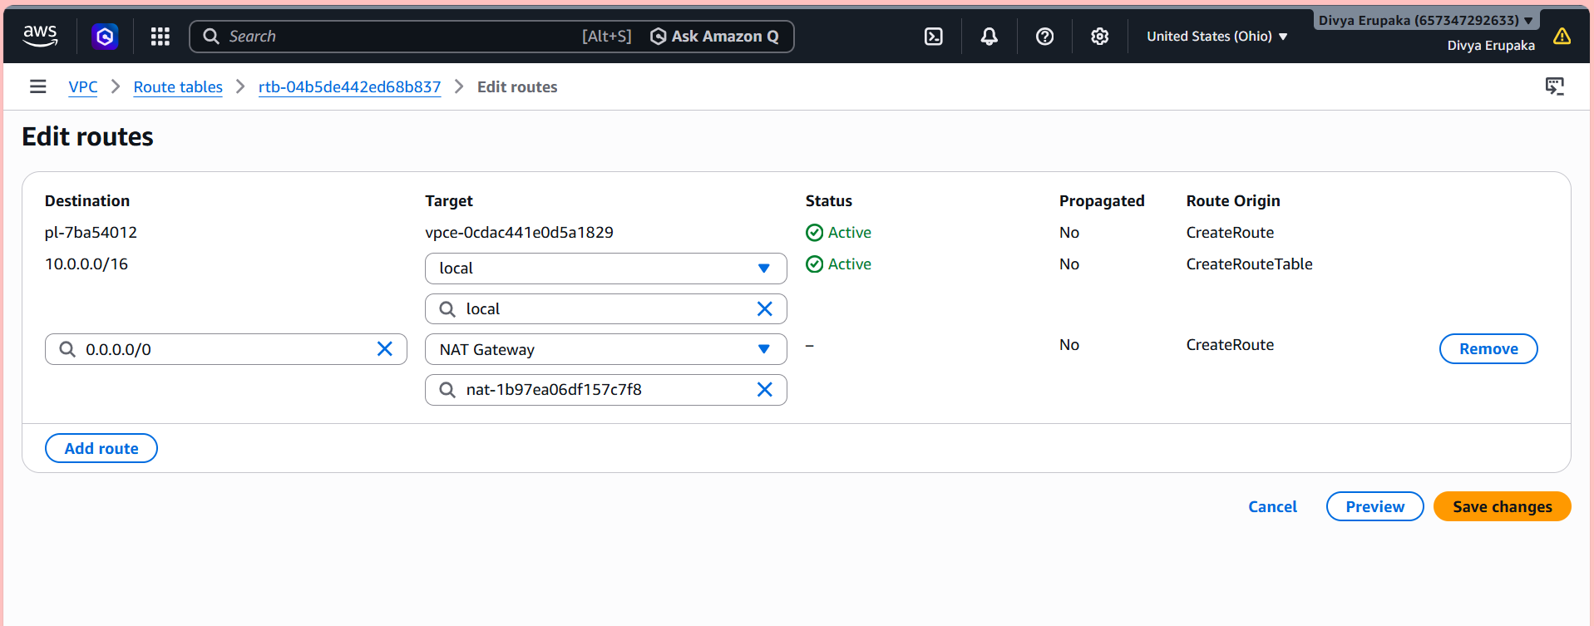
Step 9: Connect to Public EC2 Instance
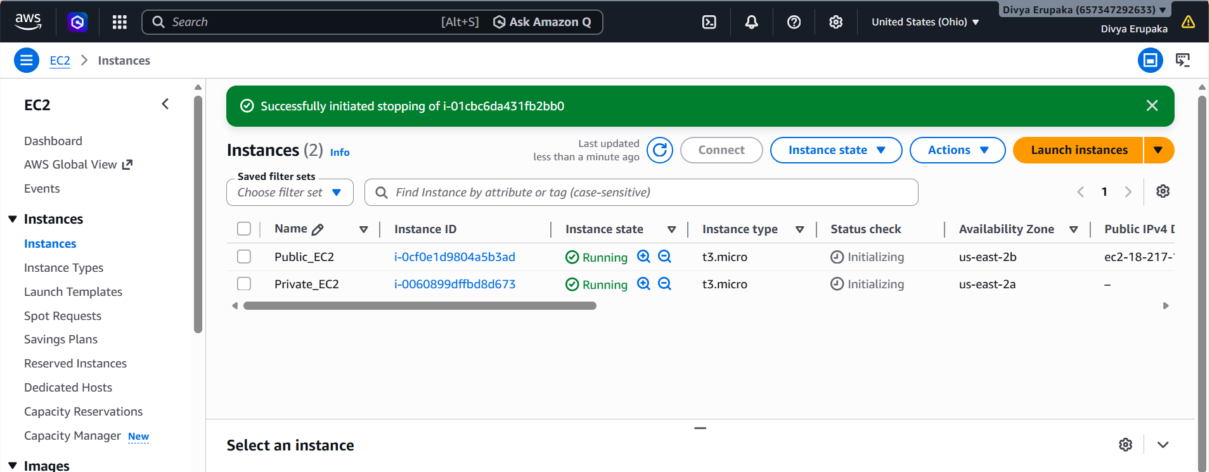
Since private EC2 instances do not have public IPs, connect first to the Bastion Host.
From local system:
ssh -i Techie.pem ec2-user@<Public-IP>
Example:
ssh -i Techie.pem ec2-user@18.xx.xx.xx

Step 10: Connect to Private EC2 Instance
From the public EC2 instance:
ssh -i Techie.pem ec2-user@<Private-IP>
Example:
ssh -i Techie.pem ec2-user@10.0.x.x
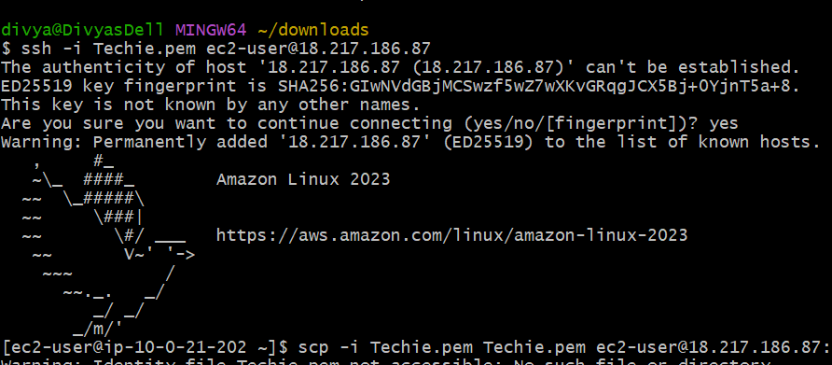
Important Security Group Configuration
The private EC2 Security Group must allow SSH access from the VPC.
Example inbound rule:
Type | Port | Source
SSH | 22 | 10.0.0.0/16

Step 11: Verify Internet Access from Private EC2
Once connected to private EC2, run:
ping google.com
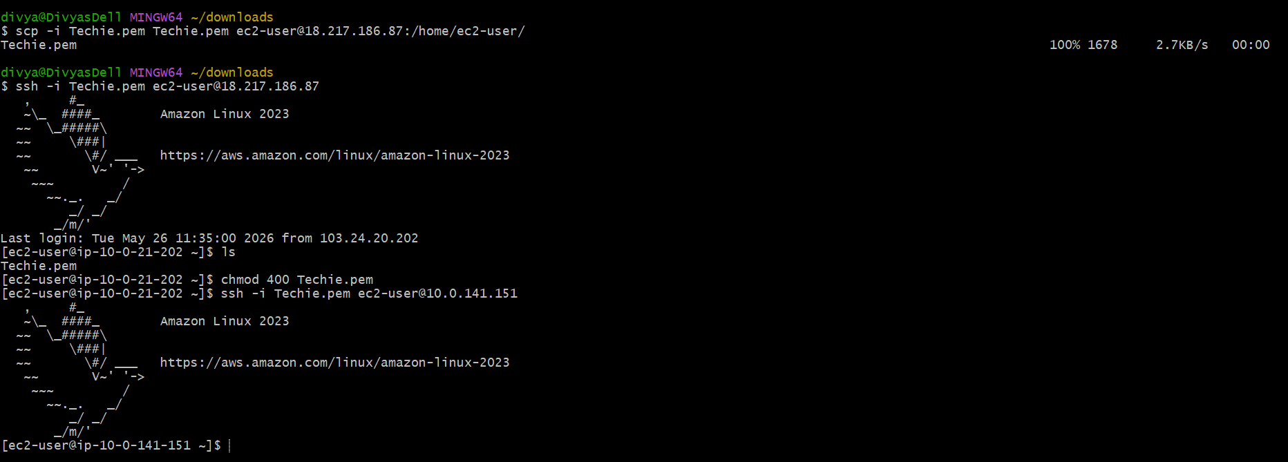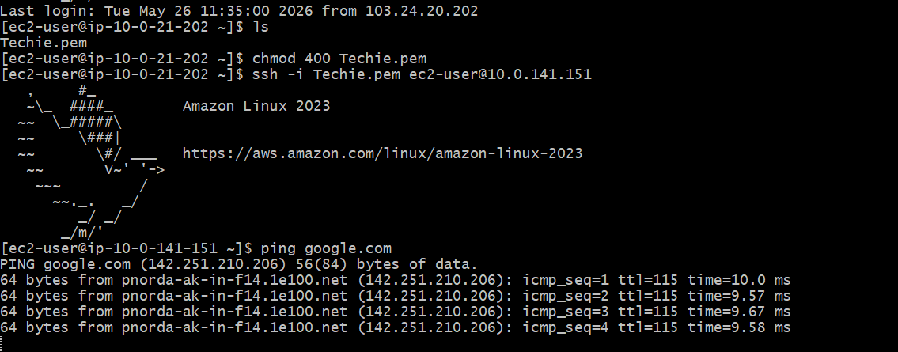

- Install Apache Tomcat in private EC2 and deploy a sample app.
Objective: The objective of this task is to install Apache Tomcat on a private EC2 instance using Java 21 and deploy a sample web application securely inside the private subnet in Amazon Web Services.
The private EC2 instance uses the NAT Gateway for outbound internet access while remaining inaccessible directly from the public internet.
Expected Outcome
After successful completion:
- Java 21 installed successfully
- Apache Tomcat installed successfully
- Tomcat service running on port 8080
- Sample application deployed successfully
- Application accessible internally within VPC
- Private EC2 remains secure in private subnet

Prerequisites
Before starting, ensure the following resources already exist:
- Custom VPC
- Public Subnet
- Private Subnet
- NAT Gateway
- Public EC2 (Bastion Host)
- Private EC2 Instance
- Internet access from private EC2 through NAT Gateway

Architecture
Laptop
|
Public EC2 (Bastion Host)
|
Private EC2
|
Apache Tomcat

Step 1: Connect to Public EC2
From local system:
ssh -i Techie.pem ec2-user@<Public-IP>
Example:
ssh -i Techie.pem ec2-user@18.xx.xx.xx

Step 2: Connect to Private EC2
From public EC2:
ssh -i Techie.pem ec2-user@<Private-IP>
Example:
ssh -i Techie.pem ec2-user@10.0.x.x
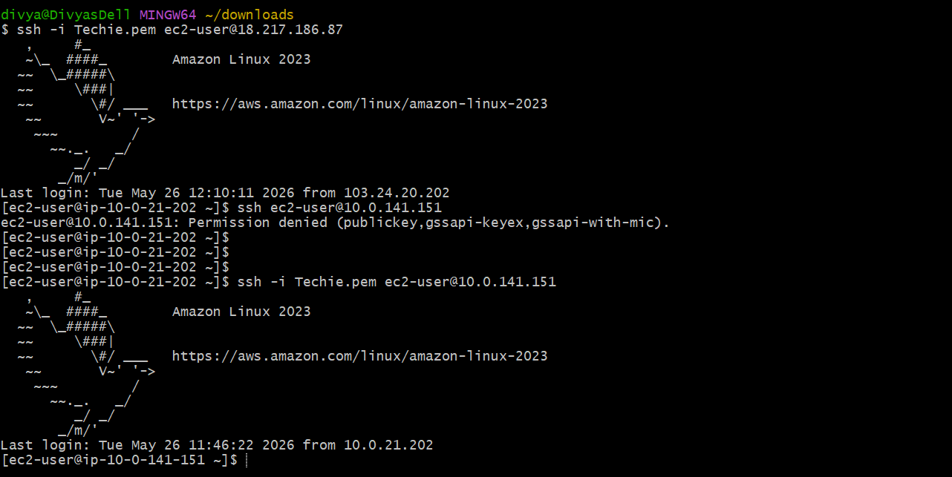
Step 3: Verify Internet Connectivity
Inside private EC2 run:
ping google.com
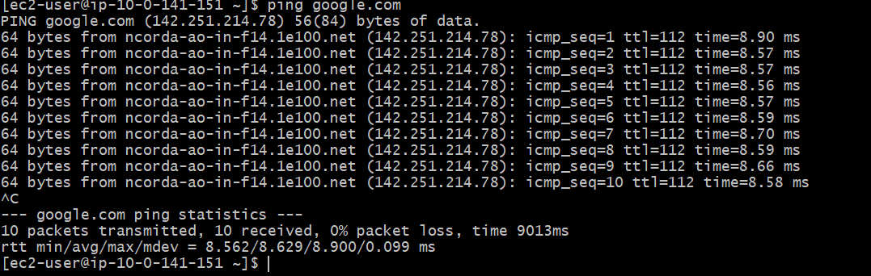
Step 4: Update System Packages
For Amazon Linux 2023: sudo dnf update -y
Install Java 21: sudo dnf install java-21-amazon-corretto -y
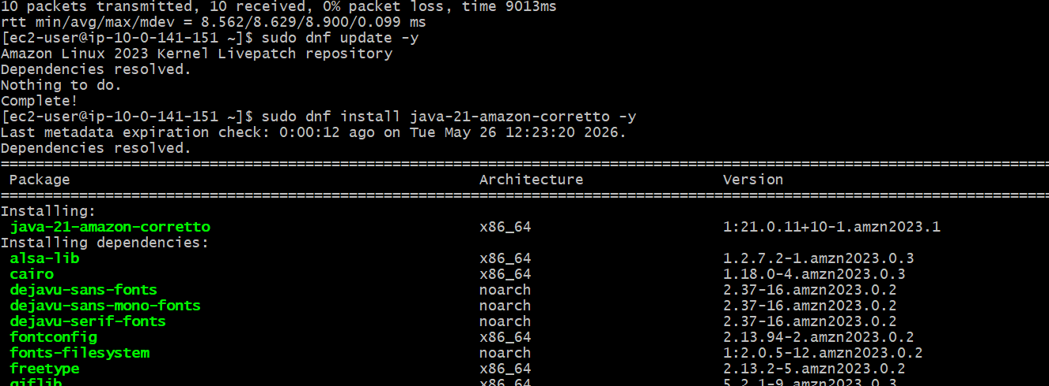
Step 6: Verify Java Installation
Run: java -version
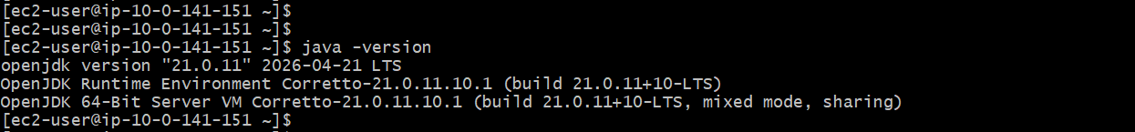
Step 7: Download Apache Tomcat
Move to temporary directory: cd /tmp
Download Tomcat 10.1.55
Run: wget https://downloads.apache.org/tomcat/tomcat-10/v10.1.55/bin/apache-tomcat-10.1.55.tar.gz
Verify Download
Run: ls
Expected:apache-tomcat-10.1.55.tar.gz
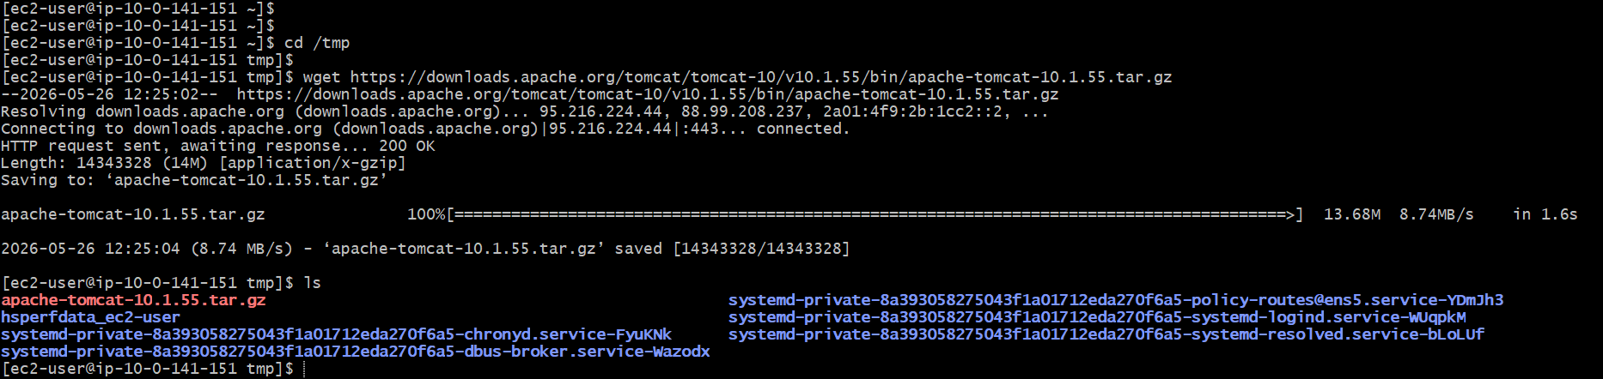
Extract Tomcat Package
Run: tar -xvzf apache-tomcat-10.1.55.tar.gz
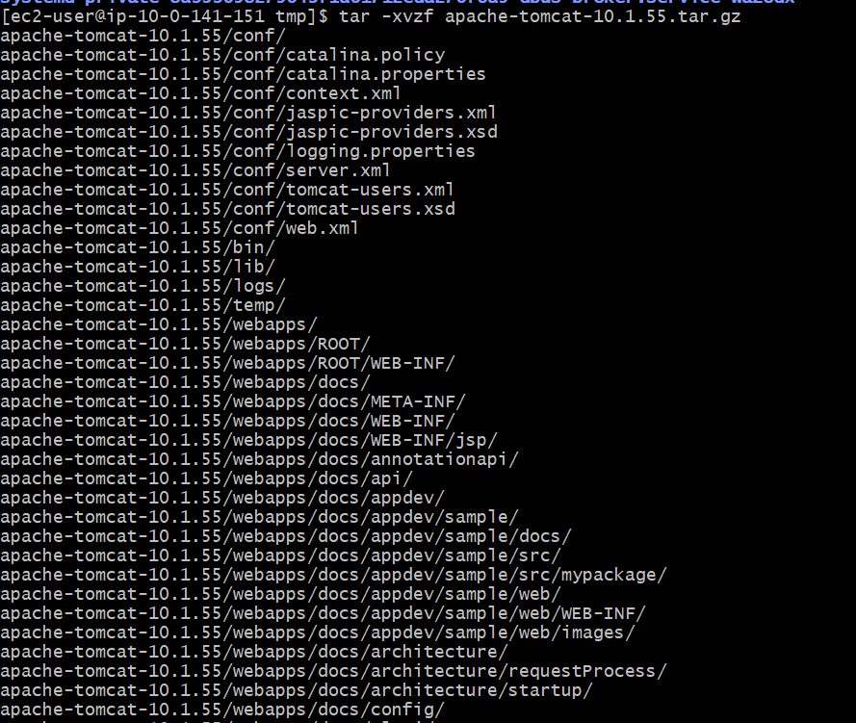
Move Tomcat to /opt
Run:
sudo mv apache-tomcat-10.1.55 /opt/tomcat

Give Execute Permission
Run:
sudo chmod +x /opt/tomcat/bin/*.sh

Start Tomcat
Run:
/opt/tomcat/bin/startup.sh
Expected:
Tomcat started.

Verify Tomcat Process
Run:
ps -ef | grep tomcat

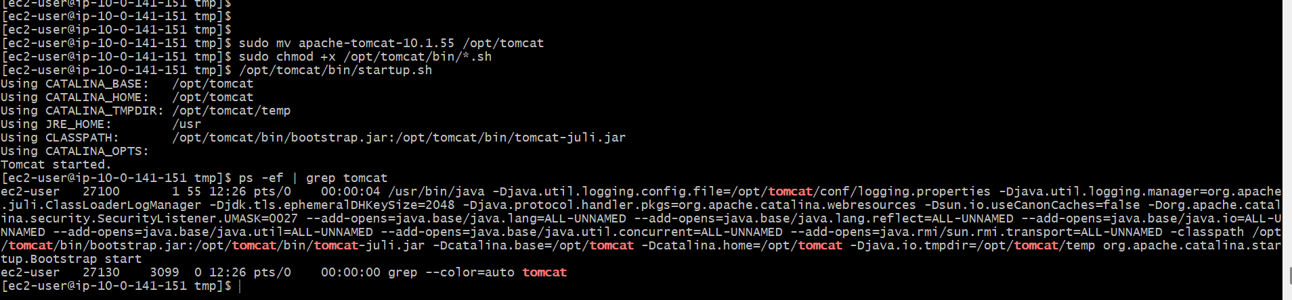
Configure Security Group
Open the private EC2 Security Group.
Add inbound rule:
Type | Port | Source
Custom TCP | 8080 | 10.0.0.0/16
Save rules.
Deploy Sample Application
Navigate to webapps directory:
cd /opt/tomcat/webapps
Create sample application directory:
sudo mkdir sampleapp
Create sample JSP page:
echo "<h1>Apache Tomcat 10 Application Deployed Successfully</h1>" | sudo tee /opt/tomcat/webapps/sampleapp/index.jsp
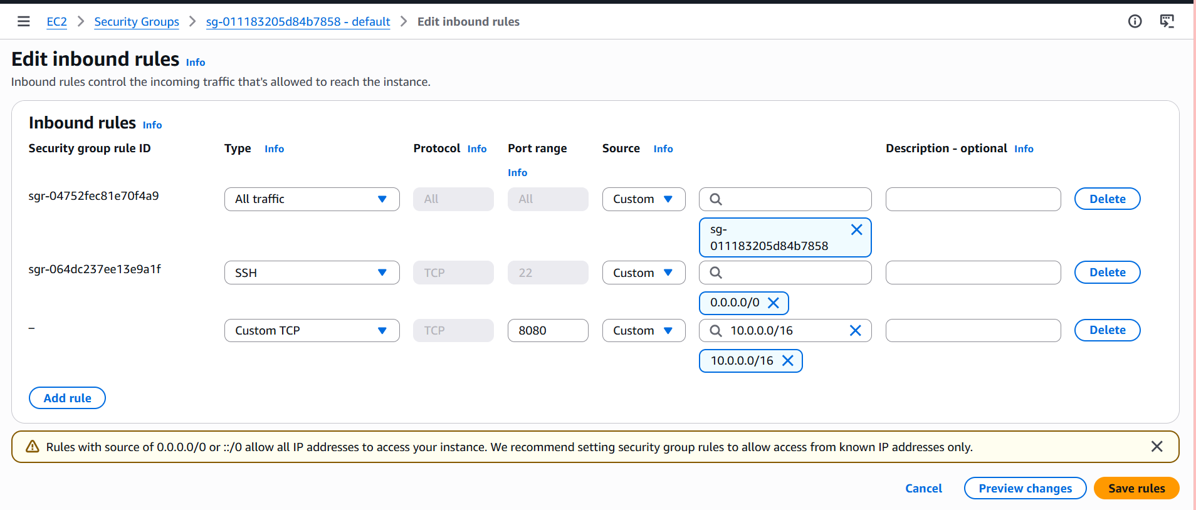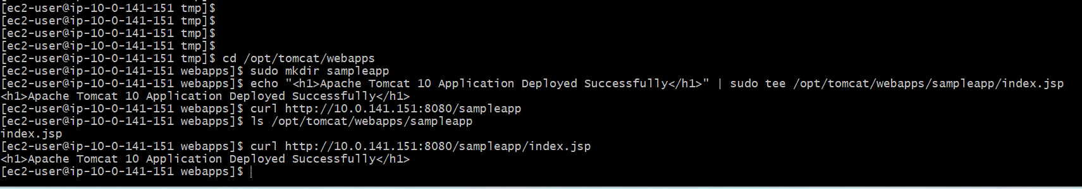
- Configure VPC flow logs and store the logs in S3 and CloudWatch.
Objective: Enable VPC Flow Logs in Amazon Web Services to monitor network traffic in a VPC and store logs in:
- Amazon CloudWatch Logs
- Amazon S3 bucket
This helps in:
- Network monitoring
- Security auditing
- Troubleshooting connectivity issues
- Traffic analysis

Expected Outcome
After completion:
- VPC Flow Logs enabled successfully
- Logs delivered to CloudWatch Logs
- Logs stored in S3 bucket
- Network traffic monitoring active
- Flow logs generating entries

Prerequisites
Ensure the following exist:
- Custom VPC
- Public & Private Subnets
- Internet Gateway
- NAT Gateway
- EC2 Instances
- IAM permissions for Flow Logs

What are VPC Flow Logs?
VPC Flow Logs capture information about IP traffic such as:
- Source & destination IP
- Ports
- Protocols
- Traffic action (ACCEPT / REJECT)
They can be enabled at:
- VPC level
- Subnet level
- Network interface (ENI / EC2 instance level)
Architecture
VPC
|
|--> Flow Logs
|------------------> CloudWatch Logs
|
|------------------> S3 Bucket

Part 1: Configure CloudWatch Logs
Step 1: Create Log Group
Go to:
- CloudWatch → Logs → Log groups
Click:
- Create log group
Enter:
- Log Group Name: vpc-flow-logs
Click:
- Create

Validation
- Log group should be created successfully

Part 2: Create S3 Bucket
Step 2: Create Bucket
Go to:
- S3 → Create bucket
Configure:
- Bucket Name: unique-vpc-flowlogs-bucket
- Region: same as VPC (recommended)
Click:
- Create bucket

Validation
- S3 bucket created successfully

Part 3: Create IAM Role
Step 3: Create Role
Go to:
- IAM → Roles → Create role
Select:
- Trusted entity: AWS Service
- Use case: VPC Flow Logs

Step 4: Attach Permissions
Attach:
- CloudWatchLogsFullAccess
Click:
- Next → Create role
Role name:
- VPCFlowLogsRole

Validation
- IAM role created successfully

Part 4: Enable Flow Logs → CloudWatch
Step 5: Open VPC Console
Go to:
- VPC → Your VPC

Step 6: Create Flow Log
Click:
- Flow Logs → Create flow log
Configure:
Setting | Value
Filter | ALL
Destination | CloudWatch Logs
Log Group | vpc-flow-logs
IAM Role | VPCFlowLogsRole
Interval | 1 minute
Click:
- Create flow log

Validation
- Flow log status = ACTIVE

Part 5: Enable Flow Logs → S3
Step 7: Create Second Flow Log
Click:
- Create flow log again
Configure:
Setting | Value
Filter | ALL
Destination | S3
Bucket ARN | arn:aws:s3:::your-bucket-name
Click:
- Create flow log

Validation
- Second flow log becomes ACTIVE
